SUBCOURSE EDITION
MM0324 6

FM RADIO RECEIVERS

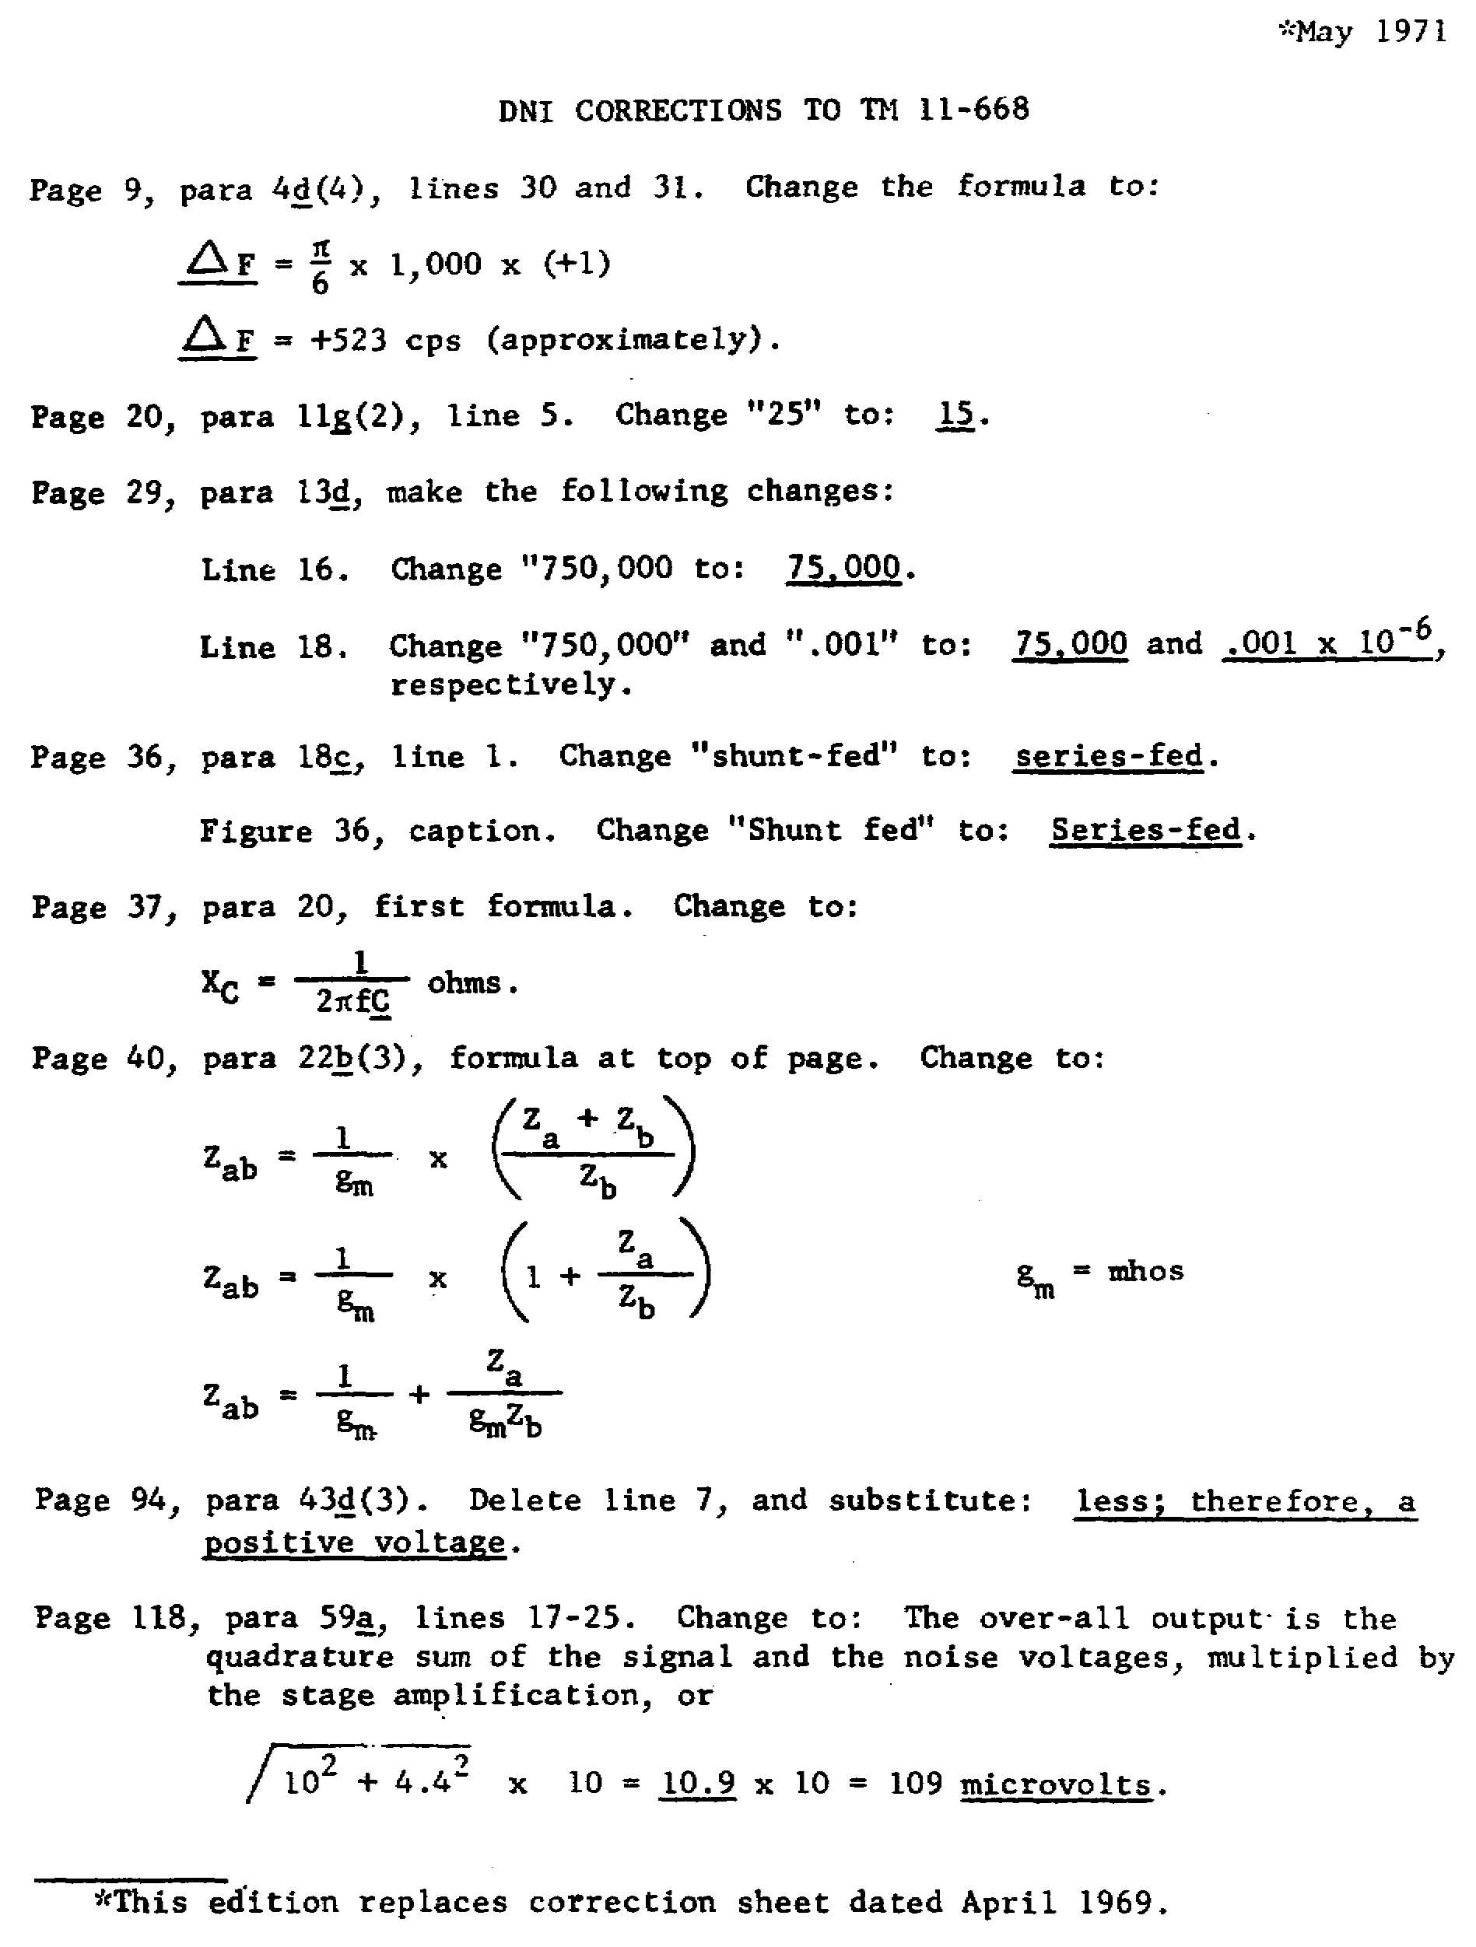
i

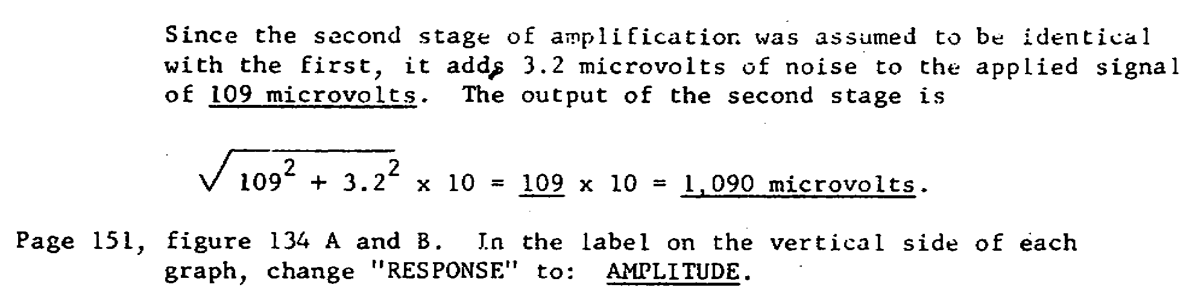

PLEASE NOTE

Proponency for this subcourse has changed from Signal (SS) to Missile & Munitions (MM).

* * * IMPORTANT NOTICE * * *

THE PASSING SCORE FOR ALL ACCP MATERIAL IS NOW 70%

PLEASE DISREGARD ALL REFERENCES TO THE 75% REQUIREMENT.

ii

SIGNAL SUBCOURSE 324, FM RADIO RECEIVERS

INTRODUCTION

The first step in troubleshooting a receiver is to determine which functions are not operating correctly. A receiver may receive signals when used with a speaker, but not with a headset. A receiver may operate correctly on channel 1 but not on channel 2, or it may operate satisfactorily without squelch, but fail to operate with squelch.

To determine the probable cause of these malfunctions, you must be thoroughly grounded in the theory of operation of each stage in the receiver.

This subcourse is written to make you aware of the different types of circuits used in FM receivers.

This subcourse consists of four lessons and an examination, as follows:

Lesson 1. RF Amplifiers

Lesson 2. Mixers, Converters, and Local Oscillators

Lesson 3. IF Amplifiers, Limiters, and Detectors

Lesson 4. Special Circuits and Alignment

Examination

Credit Hours: 10

Proponency for this subcourse has changed from Signal (SS) to Missile and Munitions (MM).

Texts and materials furnished:

Subcourse Booklet

#TM 11-668, F-M Transmitters and Receivers; September 1952

Corrections to TM 11-668

Examination

1

LESSON 1

RF AMPLIFIERS

SCOPE Block diagram of basic FM receiver; principles of operation of RF amplifiers to include single and two-stage circuits.

CREDIT HOURS 2

TEXT ASSIGNMENT TM 11-668, para 52-61, 69-71; Attached Memorandum, para 1-1 thru 1-3

MATERIALS REQUIRED None

SUGGESTIONS Read the assignment in TM 11-668 before you read the attached memorandum.

LESSON OBJECTIVES

When you have completed this lesson, you will be able to:

1. Determine the level of the noise voltage at the RF amplifier.

2. Determine the input signal requirements for given RF bandwidths.

3. Determine the current, voltage, and signal changes that occur when the AVC and AGC voltages are changed.

4. Distinguish among the various circuit configurations that are used as RF amplifiers.

5. Analyze the various types of RF amplifiers.

ATTACHED MEMORANDUM

1-1. TRANSISTOR CONFIGURATIONS OF RF AMPLIFIERS

There are three principal criteria involved in selecting the transistor configuration to be used as an RF amplifier: power gain, impedance matching, and internal feedback. Based on these three items, the common-emitter configuration is generally chosen. The common-base configuration is chosen at times, but the common-collector configuration is seldom selected.

a. Power Gain. The common-emitter configuration offers the power gain, better than 10 decibels (db) above the common-base type. The use of the

2

common-base configuration cannot be discounted completely, because the power gain is substantial and often adequate. Because power gain is usually a major requirement for high-frequency applications, the relatively low power gain of the common-collector circuit detracts greatly from its usefulness.

b. Impedance Matching. Maximum power gain can be realized only by perfect impedance matching between the output of one stage and the input of the succeeding stage. Since the difference between the input resistance and the output resistance is least for the common-emitter circuit, matching stages of common-emitter amplifiers is not so difficult. By contrast, the marked difference between the input and output resistance of common-base and common-collector circuits makes impedance matching quite difficult for these types. Thus, the common-emitter amplifier circuit has a decided advantage with regard to impedance matching for power transfer.

c. Internal Feedback. The common-emitter amplifier, however, has more feedback than the common-base amplifier. Because the common-base amplifier has the least amount of internal feedback, it does not require neutralization and is preferred in applications where stability, accurately controlled gain, and interchangeability are required. The internal feedback for the common-collector configuration is far greater than that of the other two configurations; thus, the common-collector amplifier is a poor selection if interaction between the input and output circuits is undesirable.

d. Circuit Selection. All things considered, the common-emitter circuit is generally chosen for use as both RF and IF amplifiers. The common-base circuit is used when feedback must be kept to an absolute minimum. Hence the low power gain and excessive feedback of the common-collector configuration makes it virtually unsuitable for RF and IF amplifiers.

1-2. COUPLING SCHEMES

Both RF and IF amplifier circuits are generally designed for a relatively narrow band of frequencies. Consequently, tuned coupling circuits are used to achieve the desired selectivity and power transfer. An IF amplifier circuit is designed for a particular center frequency, whereas an RF amplifier is designed so that it can be tuned over a range of frequencies. Discounting this difference, RF and IF amplifiers are essentially alike. The same coupling schemes can be used for both types of circuits.

a. Connections. Tuned coupling circuits for narrow-band amplifiers are shown in figure 1-1. The points 1, 1' and 2, 2' of each circuit correspond to the points of connection 1, 1' and 2, 2' of the block diagram in the figure. The output impedance of amplifier M1 is connected between 1 and 1'. The input impedance to amplifier M2 is connected between 2 and 2'.

b. Output Impedance. All of the circuits in figure 1-1 match a high output impedance to a low input impedance. Since a parallel resonant circuit is connected between points 1 and 1' in each case, a high impedance is realized between these points for each of the circuits.

c. Coupling for Common-Base Circuits. In circuits A and B, the input impedance of M2 is inserted directly into the parallel resonant circuit. Either of these two arrangements is suitable for a common-base amplifier which has a very low input resistance. Since the inserted resistance is

3

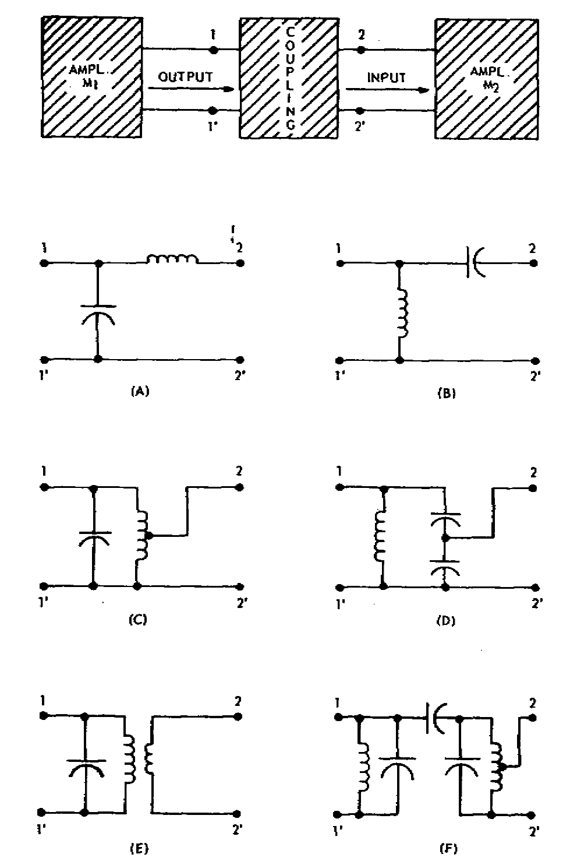

Figure 1-1. Tuned coupling arrangements for RF and IF amplifiers.

small, it is possible to make the Q of the resonant circuit high, thereby obtaining good selectivity and the required high impedance between points 1 and 1'.

d. Coupling for Common-Emitter Circuits. For coupling common-emitter amplifiers whose input resistance is comparatively high, circuits C through F are more suitable. In circuit C, the low output impedance is matched to the input impedance of M2 by tapping the tank inductance. In circuit D, the desired impedance match is obtained by tapping off between capacitors of properly proportioned values. Circuit E illustrates matching by the step-down action of a transformer from a tuned primary to an untuned secondary of fewer turns. Lastly, circuit F shows a double-tuned capacitively coupled network. Note that the inductance is tapped for the proper impedance to match that of the input of M2. Better selectivity can be obtained by using this network because both output and input can be tuned.

e. Coupling Summary. There are numerous interstage coupling schemes possible. Only the more important ones that can be designed to meet the selectivity and matching requirements ordinarily encountered have been presented in this attached memorandum. Special circuits and devices can be employed for extraordinary requirements.

4

1-3. TRANSISTORIZED RF AMPLIFIER

The RF amplifier stages illustrated in figure 1-2 are representative of those in a typical two-stage circuit used in an FM receiver. The two stages contain PNP transistors connected in the common-base configuration. Coupling between the antenna and the first RF amplifier, and between the two amplifiers, is accomplished by circuits that are variations of the one shown in E of figure 1-1. Operating the two RF amplifiers in the common-base configuration eliminates the necessity for neutralization and minimizes changes in RF gain that may be caused by variations in the supply voltage. The three tunable tank circuits provide a means of obtaining the desired RF selectivity.

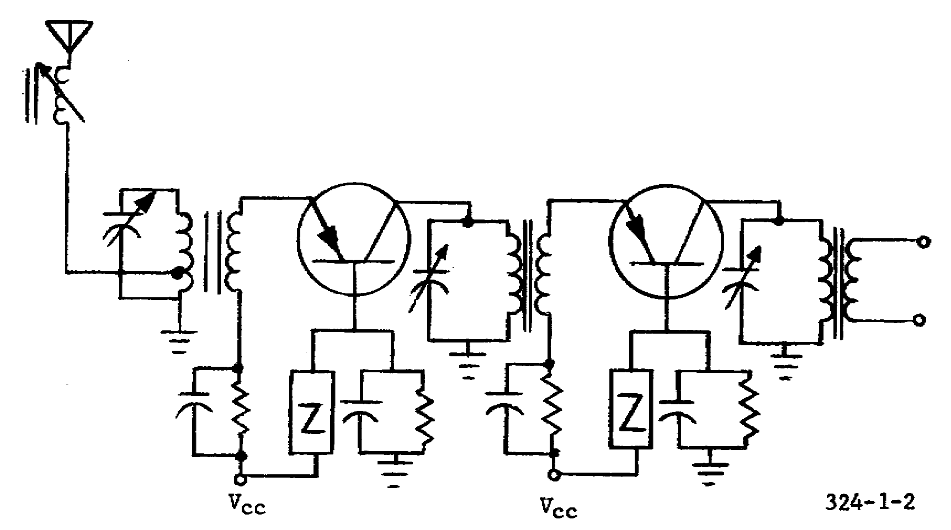

Figure 1-2. Transistorized RF amplifier.

LESSON EXERCISES

In each of the following exercises, select the ONE answer that BEST completes the statement or answers the question. Indicate your solution by circling the letter opposite the correct answers in the subcourse booklet.

1. The double superheterodyne receiver is often used in very high frequency military communications. Compared with the standard superheterodyne, the double superheterodyne has the advantage of

a. greater frequency deviation.

b. fewer stages for portable equipment.

5

c. immunity from undesirable AM signals.

d. good image rejection and adjacent-channel selectivity.

2. Assume that the input circuit of an RF amplifier in an FM receiver has a resistance of 10,000 ohms. If the receiver is to have a bandwidth of 100 kHz, the minimum incoming signal that will override the noise and produce a useful receiver output is approximately

a. 3 microvolts. c. 10 microvolts.

b. 5 microvolts. d. 30 microvolts.

3. Assume that you have analyzed the response curve of the RF amplifier in an FM receiver and found that the response is essentially flat from 101.92 MHz to 102.08 MHz. If the input circuit resistance is 7,000 ohms, the average input circuit noise voltage is

a. less than 2 microvolts.

b. between 2 and 3 microvolts.

c. between 3 and 5 microvolts.

d. greater than 5 microvolts.

4. Although the elimination of amplitude variations reduces the noise in an FM receiver, some interference results from fluctuation noises in the electron tubes. These noises are caused by variations in the

a. positive-grid currents, size of the space charge, and cathode emission.

b. size of the space charge, cathode emission, and currents induced in the control grid.

c. cathode emission, currents induced in the control grid, and positive-grid currents.

d. currents induced in the control grid, positive-grid currents, and size of the space charge.

5. Assume that the equivalent noise resistance of a given pentode mixer produces a noise signal of 3.2 microvolts. If the bandpass is to remain about 100 kHz, the equivalent noise resistance of a hexode mixer would produce a noise signal of approximately

a. 30 microvolts.

b. 20 microvolts.

c. 10 microvolts.

d. 5 microvolts.

6

6. The noise figure expresses the relative merit of a receiver which, if perfect, would have a noise figure of 0 decibel (db). The noise figure of an RF amplifier can be reduced by using

a. step-up input transformers, low input conductance tubes, or high transconductance tubes.

b. low input conductance tubes, high transconductance tubes, or bandwidth-increasing circuits.

c. high transconductance tubes, bandwidth-increasing circuits, or step-up input transformers.

d. bandwidth-increasing circuits, step-up input transformers, or low input conductance tubes.

SITUATION

Assume that the circuit shown in figure 1-3 is the amplifier in an FM tuner. The electron tube used in the circuit is a 6BJ6 remote cutoff tube whose E_{g}-I_{p} curve is shown in figure 1-4. Assume also that the screen-grid current is 3 ma.

Exercises 7 and 8 are based on the above situation.

7. When the circuit is operating normally as an RF amplifier in an FM receiver, the grid bias is -1 volt. The value of R1 required to develop this voltage must be approximately

a. 80 ohms. c. 330 ohms.

b. 100 ohms. d. 1,200 ohms.

8. Assume that the control-grid bias on the 6BJ6 tube is changed to -2 volts. Without automatic volume control (AVC), the plate current will increase 4 ma when the signal on the grid increases 1 volt. When an AVC potential of -4 volts is applied, an increase of 1 volt in the signal will cause the plate current to increase

a. less than 0.25 ma.

b. between 0.25 ma and 0.50 ma.

c. between 0.50 ma and 1 ma.

d. more than 1 ma.

9. The bandwidth of the input circuits of an RF amplifier such as shown in A of figure 112 (TM 11-668) might be increased by either

a. moving the coils closer together or using coils with higher Q.

b. using coils with higher Q or incorporating additional tuned circuits.

7

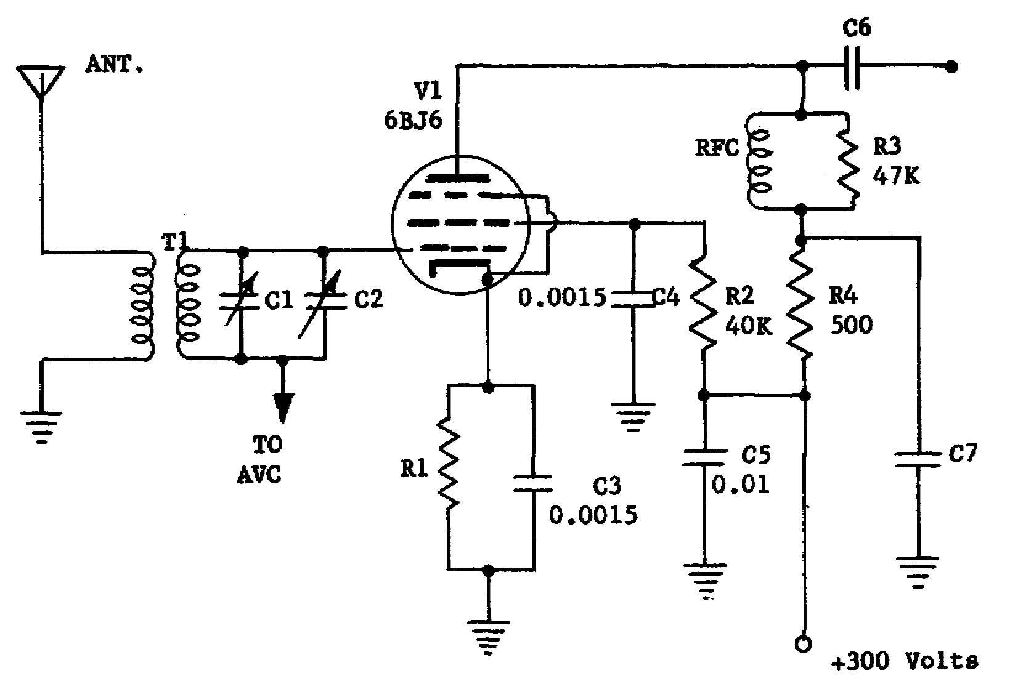

Figure 1-3. RF amplifier.

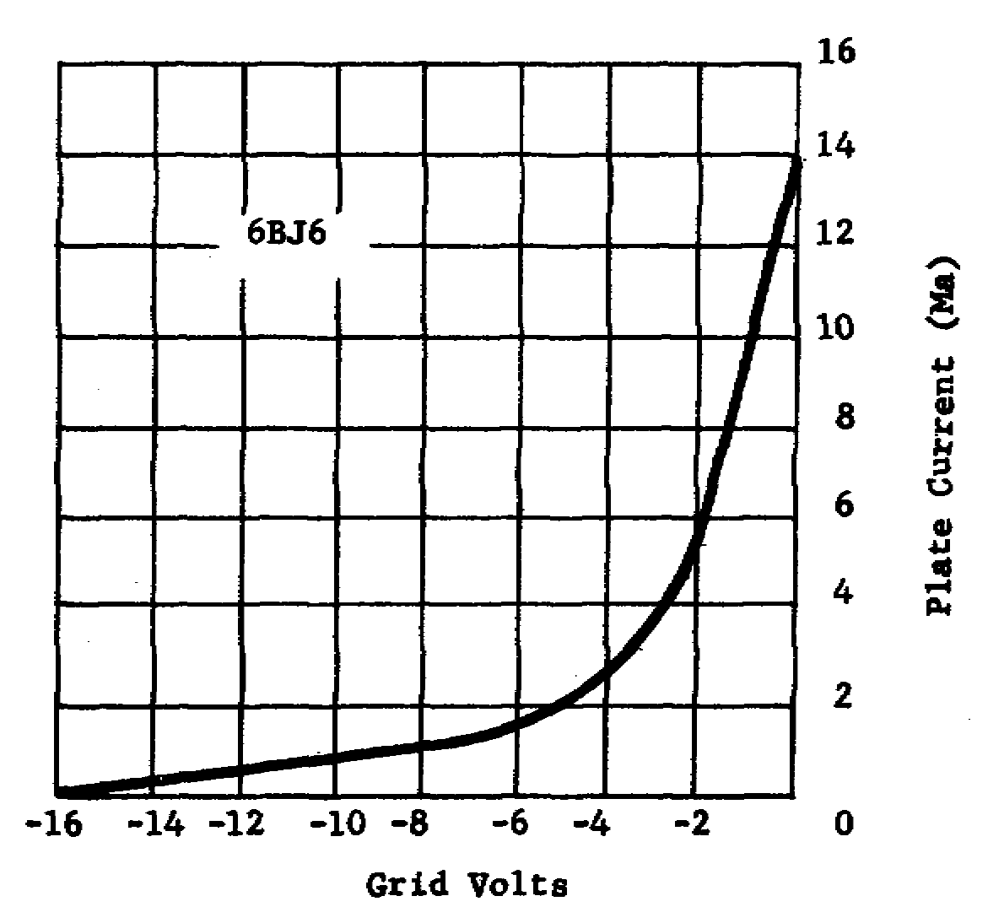

Figure 1-4. E_{g}-I_{p} curve of 6BJ6.

8

c. incorporating additional tuned circuits or moving the coils closer together.

d. moving the coils farther apart or using coils with higher Q.

10. One of the common RF amplifier arrangements in FM receivers is two triodes connected in the grounded-grid arrangement. These two grounded-grid amplifiers are normally connected to each other in a

a. cascade arrangement. c. push-pull arrangement.

b. cascode arrangement. d. paraphase arrangement.

11. In receivers operating in the extremely high frequency band, crystal mixers are used instead of electron-tube mixers. The type of RF amplifier that is most suitable for use with the crystal mixer is the

a. cathode follower type of grounded-grid amplifier.

b. single-tube amplifier with cathode grounded.

c. direct-coupled type of driven grounded-grid amplifier.

d. push-pull amplifier with plates grounded to RF.

12. The RF amplifier in an FM receiver may consist of a single cathode follower with the plate at RF ground. Compared with other RF amplifiers, the advantages of a cathode follower include

a. high gain and broad input bandwidth.

b. broad input bandwidth and good noise figure.

c. low output impedance and good noise figure.

d. high input selectivity and high input impedance.

13. With respect to noise and input signal amplitude, the type of electron-tube RF amplifier that provides the best performance and simplest construction is the

a. two-tube cascade grounded-grid amplifier.

b. direct-coupled driven grounded-grid amplifier.

c. grounded-grid amplifier driven by a cathode follower.

d. driven grounded-grid amplifier with capacitive neutralization.

14. Although remote-control tubes are often used in RF amplifiers where automatic gain control (AGC) is desired, sharp cutoff tubes may be used if

a. a positive AGC voltage is applied to the grid.

b. the local oscillator is separated from the mixer.

9

c. the AGC voltage does not drive the tube beyond cutoff.

d. both RF amplifier tubes are included in the same envelope.

15. The tuned-circuit gain of a receiver's input can be adversely affected by the length of the leads between the tuning elements. The tuning device that provides one of the most efficient means of VHF channel selection is the

a. turret tuner. c. guillotine tuner.

b. detent selector. d. pushbutton selector.

16. When selecting a transistor circuit for use as an RF amplifier, the three criteria on which the selection must be based are

a. power gain, impedance matching, and internal feedback.

b. voltage gain, impedance matching, and internal feedback.

c. impedance matching, input resistance, and input capacitance.

d. internal feedback, output impedance, and external feedback.

17. Assume that two RF amplifier stages must be designed, with one stage having a high power gain and the second having accurately controlled gain and stability. The two configurations that satisfy these two requirements are the

a. common base and the common emitter, respectively.

b. common emitter and the common base respectively.

c. common collector and the common base, respectively.

d. common emitter and the common collector, respectively.

18. Generally, a tuned coupling circuit is used to couple stages of RF amplifiers. The type of tuned coupling circuit used is based upon the desired degree of

a. feedback and sensitivity.

b. selectivity and sensitivity.

c. power transfer and feedback.

d. selectivity and power transfer.

19. The coupling circuit shown in F of figure 1-1 is commonly used in RF and IF amplifier circuits when good selectivity is needed. This circuit can provide good selectivity because it

10

a. employs capacitive coupling.

b. uses tapped inductances.

c. has a tunable input and output.

d. has a step-down transformer.

20. The two stages of RF amplification shown in figure 1-2 do not require neutralizing circuits because the amplifiers use

a. common-base configurations.

b. coupling circuits to suppress the undesired feedback.

c. thermistors in the base circuits to compensate for the feedback.

d. step-down transformers to prevent the transfer of unwanted frequencies.

CHECK YOUR ANSWERS WITH LESSON 1 SOLUTION SHEET PAGES 55 AND 56.

11

LESSON 2

MIXERS, CONVERTERS, AND LOCAL OSCILLATORS

SCOPE Principles, purposes, requirements, and types of mixers, converters, and oscillators used in FM receivers.

CREDIT HOURS 2

TEXT ASSIGNMENT TM 11-668, para 62-71;
Attached Memorandum, para 2-1 thru 2-5

MATERIALS REQUIRED None

SUGGESTIONS Read the assignment in TM 11-668 before you read the attached memorandum.

LESSON OBJECTIVES

When you have completed this lesson, you will be able to:

1. Determine output frequencies and the conversion gain of a mixer stage.

2. Describe circuit devices that can be operated as mixers and converters.

3. Distinguish among the various circuit configurations that are used as local oscillators.

4. Analyze the local oscillator circuits.

ATTACHED MEMORANDUM

2-1. MIXING

a. Methods. The process of combining RF with an oscillator's frequency to produce an IF is called mixing or frequency conversion. The two basic methods of frequency conversion employed with electron tubes are also employed with transistors. The first method, a transistor that combines an oscillator frequency and a radio frequency is called a mixer. In the second method, only one transistor functioning as both oscillator and mixer is used. This circuit is known as a converter.

b. Output Frequencies. When a transistor is used as a mixer or a converter, it is operated on the curved portion of its dynamic characteristic curve. Under these conditions, when two frequencies are applied to the transistor input, four major frequencies are produced in the output. Two of the output frequencies are the original frequencies that were present at the input. Another one of the output frequencies is a frequency that is equal to the sum

12

of the two original frequencies. The remaining frequency that is present in the output is a frequency equal to the difference of the two original frequencies. In most receivers only the difference frequency is of interest, and all of the other frequencies must be filtered out. The difference frequency used in a receiver is referred to as the IF.

c. Mixer Output. The input and output waveforms of a mixer stage are shown in A of figure 2-1. The input radio frequency is represented by F1, and the input oscillator frequency is represented by F2. The two input frequencies applied to the mixer stage produce four prominent output frequencies. The original radio frequency present in the output is represented by F1₁. The original oscillator frequency present in the output is represented by F2₁. The sum of the two original frequencies is represented by F1₁ plus F2. The difference of the two original frequencies is represented by F1 minus F2.

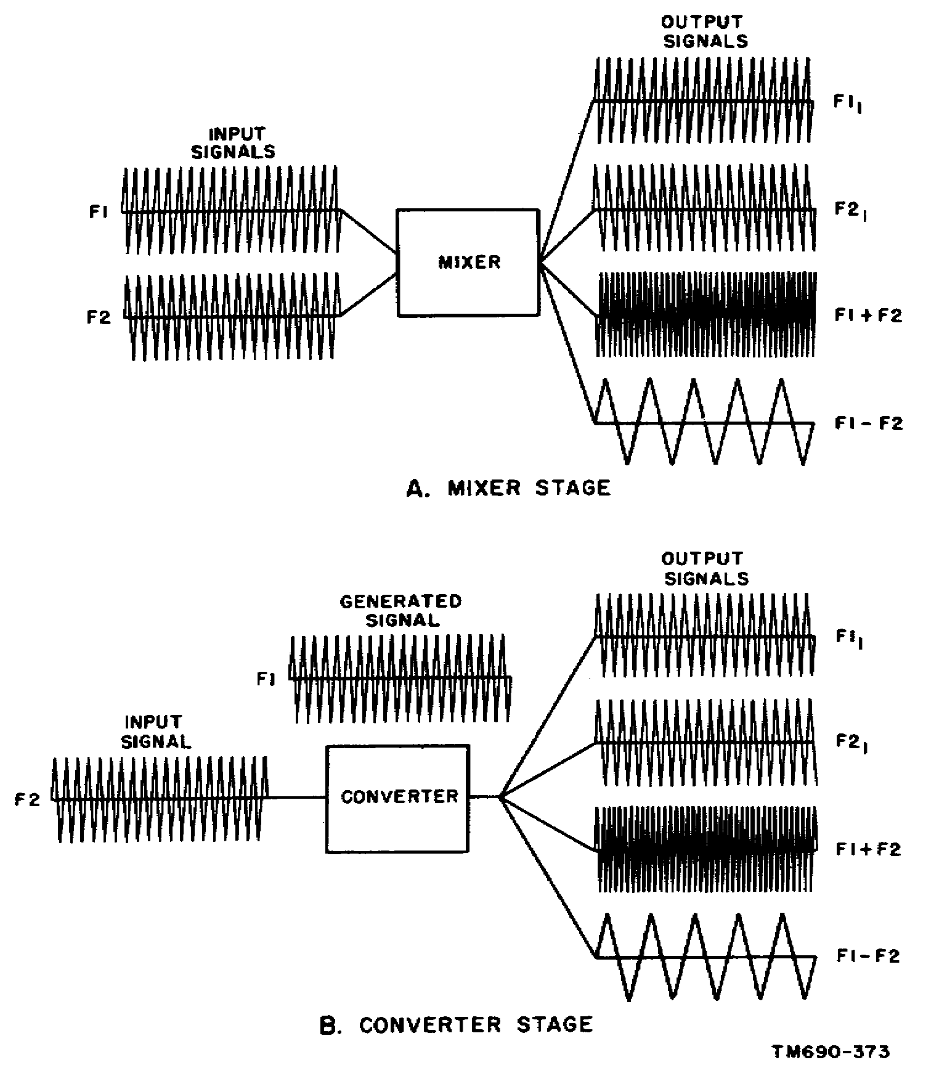

Figure 2-1. Input and output waveforms of a mixer and a converter.

13

d. Converter Output. The input and output waveforms of a converter stage are shown in B of figure 2-1. Frequency F2 is applied to the converter stage, and frequency F1 is generated within the converter stage. The two frequencies present in the converter stage produce four prominent frequencies in the output. The original radio frequency present in the output is represented by F2₁. The original generated frequency present in the output is represented by F1₁. The sum of the two frequencies is represented by F1 plus F2. The difference is represented by F1 minus F2.

2-2. INJECTION OF OSCILLATOR FREQUENCY

As shown in figure 2-2, the oscillator frequency can be fed to the base, the emitter, or the collector circuit of a mixer stage. The oscillator frequency is coupled through T3A, T3B, or T3C to the base, the emitter, or the collector, respectively. Capacitor C1 and the primary of transformer T1 form a parallel resonant circuit for the radio frequency that is coupled to the base circuit of mixer Q1. Capacitor C3 and the primary of transformer T3A, T3B, or T3C form a parallel resonant circuit for the oscillator frequency. Capacitor C2 and the primary of transformer T2 form a parallel resonant circuit for the intermediate frequency which is coupled through the transformer to the following stage.

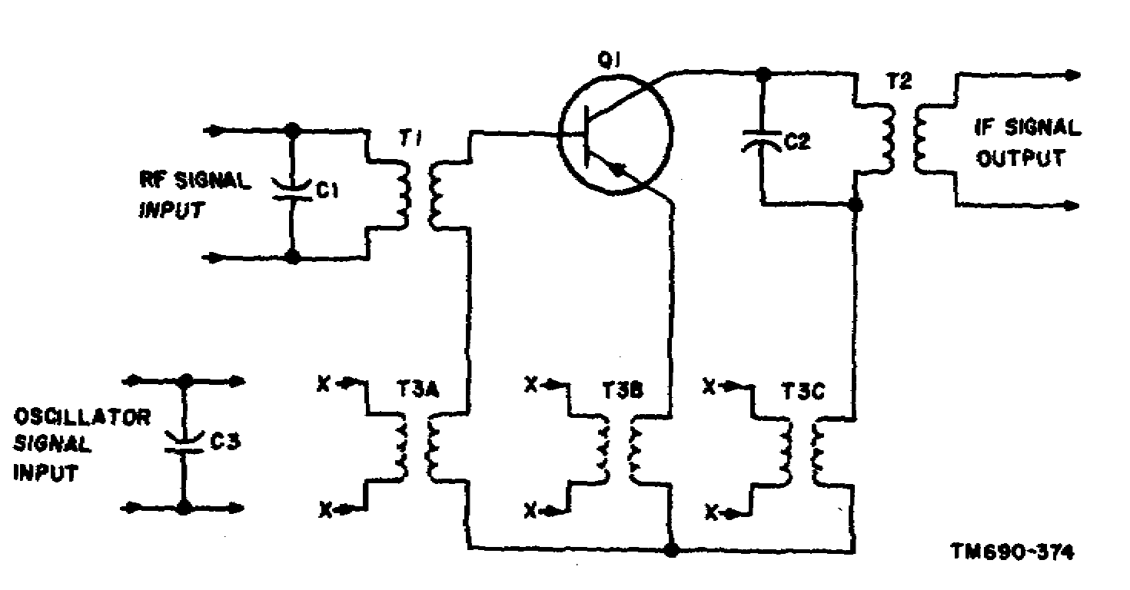

Figure 2-2. Methods of injecting an oscillator frequency into a mixer stage.

2-3. MIXER

a. Operation. A schematic diagram of a mixer stage with typical values of components is shown in figure 2-3. The RF signal is 1 MHz; the oscillator signal, 1.5 MHz; the IF signal, 500 kHz. Emitter injection is employed to couple the oscillator signal into the mixer circuit. The radio frequency injected into the base circuit and the oscillator frequency injected into the emitter circuit are heterodyned in mixer Q1. The intermediate frequency is selected by the collector tank circuit. The intermediate frequency is then coupled through transformer T3 to the following stage.

14

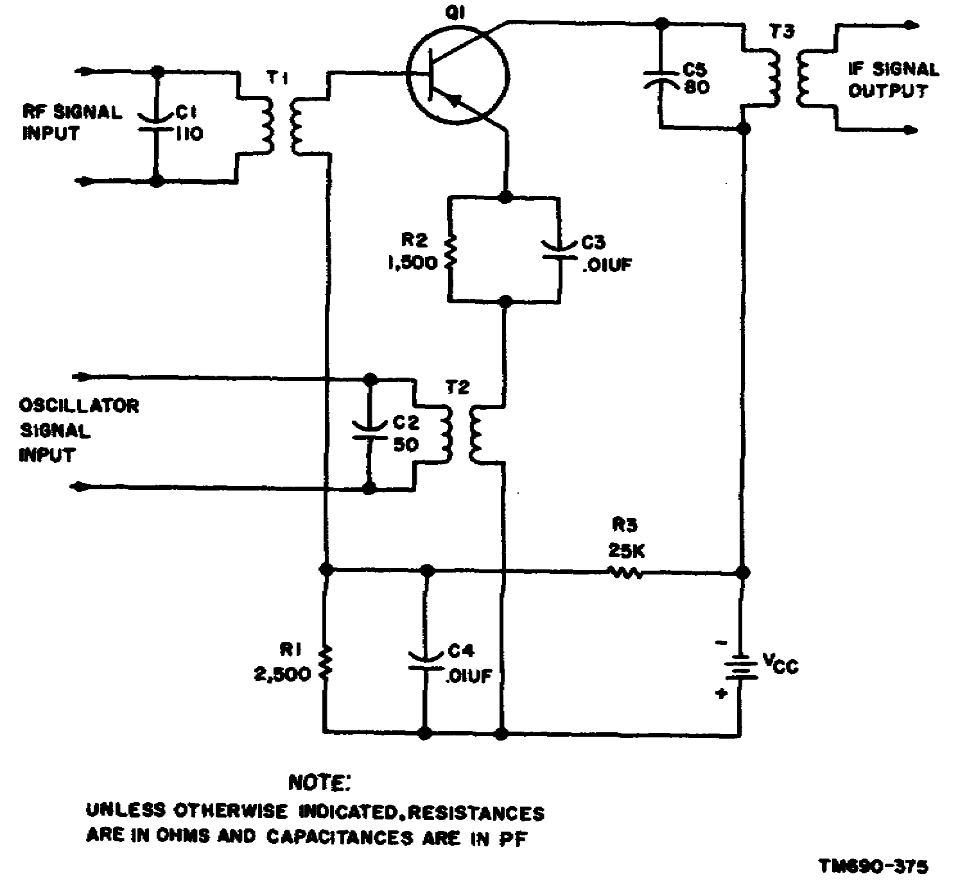

Figure 2-3. Mixer circuit.

b. Component Functions. Capacitor C1 and the primary of transformer T1 form a parallel resonant circuit for the RF signal, which is coupled through the transformer to the base circuit of Q1. Capacitor C2 and the primary of transformer T2 form a parallel resonant circuit for the oscillator frequency, which is coupled through the transformer to the emitter circuit of mixer Q1. Resistor R1 provides emitter-base bias, and resistor R3 is a voltage-dropping resistor. Capacitor C4 is a bypass capacitor. Resistor R2 is the emitter-swamping resistor. Capacitor C5 and the primary of transformer T3 form a parallel resonant circuit for the intermediate frequency which is coupled through the transformer to the following stage.

2-4. CONVERTER

a. Operation. A schematic diagram of a converter stage is shown in figure 2-4. The radio frequency injected into the base circuit and the oscillator frequency generated by converter Q1 are heterodyned in the converter. The parallel resonant circuit, consisting of capacitor C3 and the primary of transformer T3, selects the desired intermediate frequency. The intermediate frequency is then coupled through transformer T3 to the following stage.

15

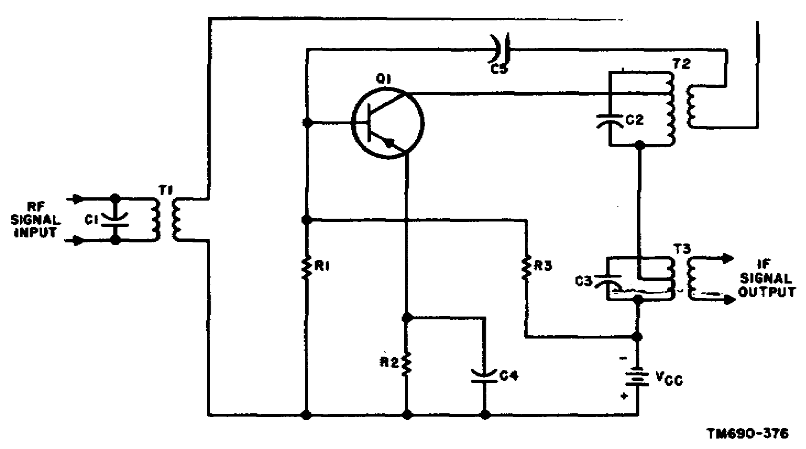

Figure 2-4. Converter circuit.

b. Component Functions. Capacitor C1 and the primary of transformer T1 form a parallel resonant circuit for the radio frequency, which is coupled through the transformer to the base circuit of converter Q1. Resistor R1 develops the emitter-base bias, and resistor R3 is a voltage-dropping resistor. Resistor R2 is the emitter-swamping resistor, and capacitor C4 is a bypass for the radio frequency. Capacitor C2 and the primary of transformer T2 form a parallel resonant circuit for the oscillator frequency. The secondary of transformer T2 provides the required feedback for the oscillator portion of converter Q1. Capacitor C5 is a dc blocking capacitor. Capacitor C3 and the primary of transformer T3 form a parallel resonant circuit for the intermediate frequency, which is coupled through the transformer to the following stage. The primaries of transformers T2 and T3 are tapped to obtain the desired selectivity.

2-5. LC OSCILLATORS

The resonant features of inductance-capacitance (LC) circuits make them very suitable for frequency determination. Moreover, such circuits are readily adaptable for feedback arrangements. Successively, the following types will be treated: tickler-coil (Armstrong), Hartley, tuned-collector tuned-base, Colpitts, and crystal-controlled oscillators.

a. Tickler-Coil. The circuit shown in figure 2-5 is practically self-explanatory inasmuch as the requirements for oscillation are apparent. The amplifying device and power supply Vcc are readily seen. Regenerative feedback is obtained by the transformer action between L1 and L2. The dots at opposite ends of these inductors indicate the phase inversion required for regeneration. Finally, frequency is determined by the collector tank circuit (L2 and C2).

16

(1) Stability depends on several factors built into this circuit. The higher the Q of the tank circuit the better the frequency stability. Bias stability is attained by the action of R2 in conjunction with R1 and C1. Resistor R1 and capacitor C1 provide a self-regulating base bias. This regulating action is identical with that obtained with grid-leak biasing of an electron-tube oscillator. Like grid-leak bias, base-leak bias builds up and adjusts itself to insure a constant output signal amplitude.

(2) Since an LC tank insures a good sinusoidal waveform, this oscillator and other LC types can be biased to operate Class C. Class C operation is preferred for its higher efficiency.

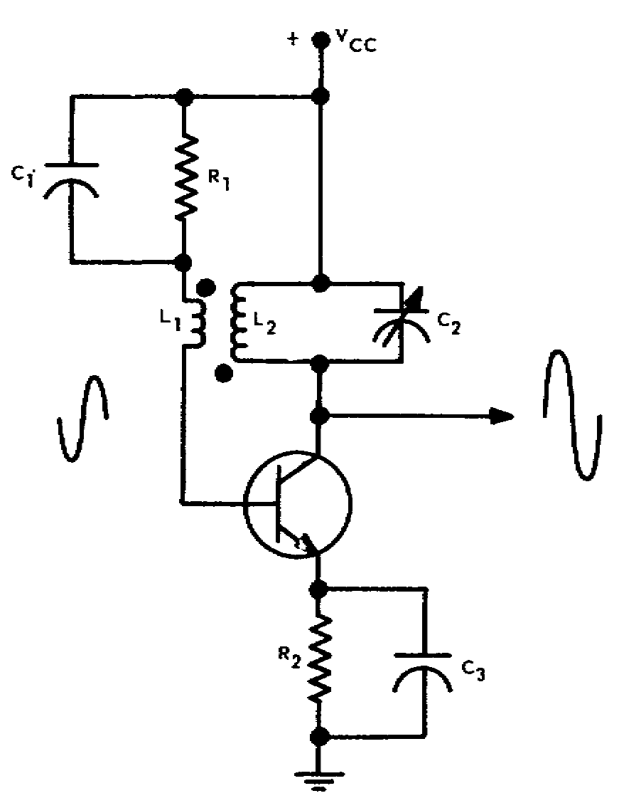

Figure 2-5. Tickler-coil oscillator.

(3) Modified versions of this type may have the tuning tank placed in the input circuit or use different transistor configurations.

b. Hartley. As in the case for electron-tube oscillators, the dc power supplied can be series fed or shunt fed. Recall that a series feed passes dc through the tank circuit, whereas a shunt feed does not. The tickler circuit shown in figure 2-5 is series fed. The Hartley oscillator circuit shown in A of figure 2-6 is shunt fed; note that no dc is applied to the tank circuit. The RF choke (RFC) blocks the signal from the power supply. Capacitor CO blocks dc and effectively passes RF. Either series or shunt feed can be used for LC oscillators.

(1) Whether series or shunt fed, the ac circuit for a Hartley oscillator is that shown in B of figure 2-6. Capacitors CO, CB (for biasing), and bypass CE are effective RF shorts. The tank circuit is common to the input and output circuits. This type oscillator is characterized by the connection made to the tank's inductance. When a single coil is tapped, there is inductive coupling and auto-transformer action. Phase inversion from collector (point c) to base (point b) can be explained by the fact that the signals at opposite ends of the coil are 180° out of phase with reference to the emitter (point e). However, inductive coupling is not necessary. The tank inductance can be made up of two separate coils, one in the base circuit (b and e) and the other in the collector circuit (c to e).

17

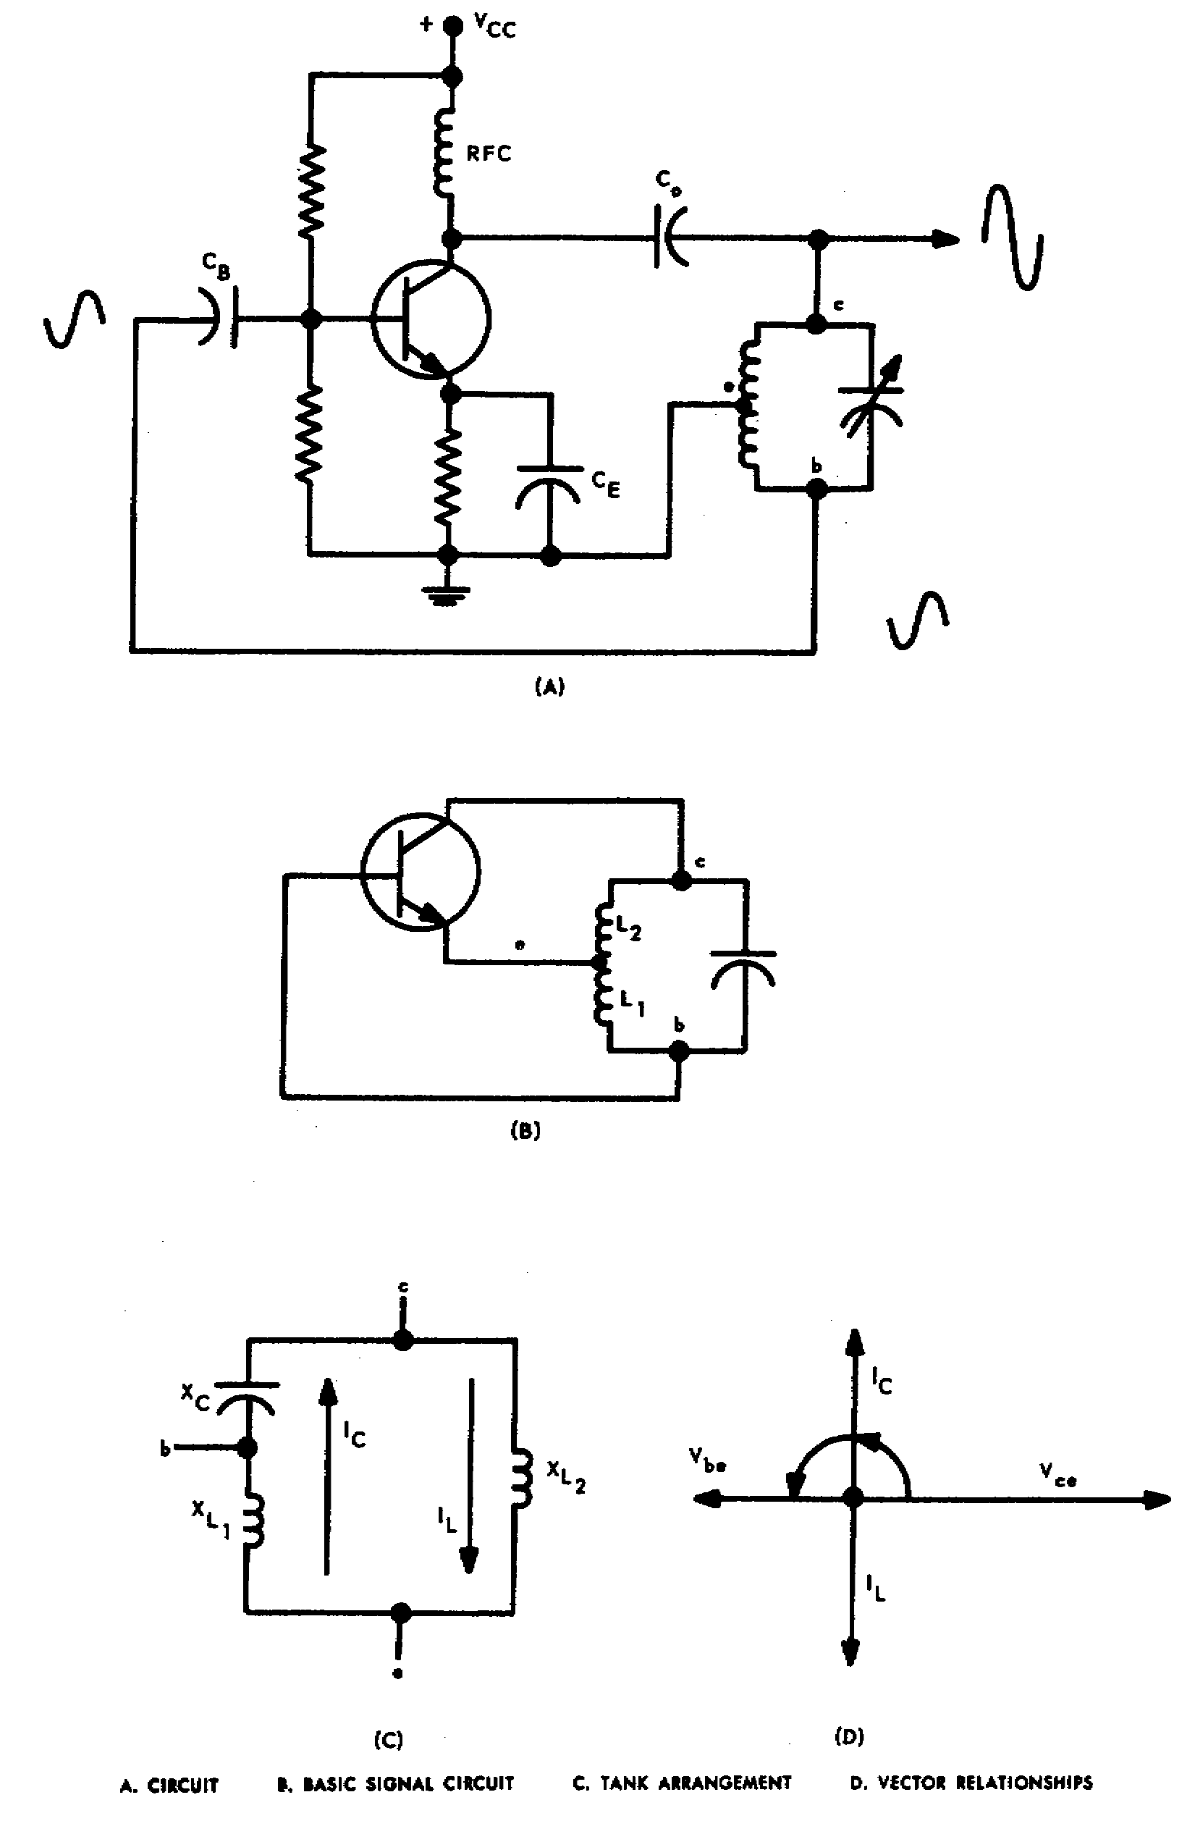

Figure 2-6. Hartley oscillator.

18

(2) Although Hartley oscillators are usually designed to have a tapped coil and inductive coupling, many other oscillatory systems that operate basically as Hartley oscillators do not have such coupling.

c. Tuned-Collector Tuned-Base Oscillator. Looking at A of figure 2-7, we find a circuit that could be an RF or IF amplifier. However, with positive feedback, the circuit becomes an oscillator.

(1) We know that a parallel tank circuit presents an inductive reactance for frequencies lower than the resonant frequency. Therefore, for some frequency below the resonant frequency, the input tank (L1 and C1) can be represented in B of figure 2-7 by XL. Likewise, the output tank (L2 and C2) can be represented by XL. Between points c and b is the
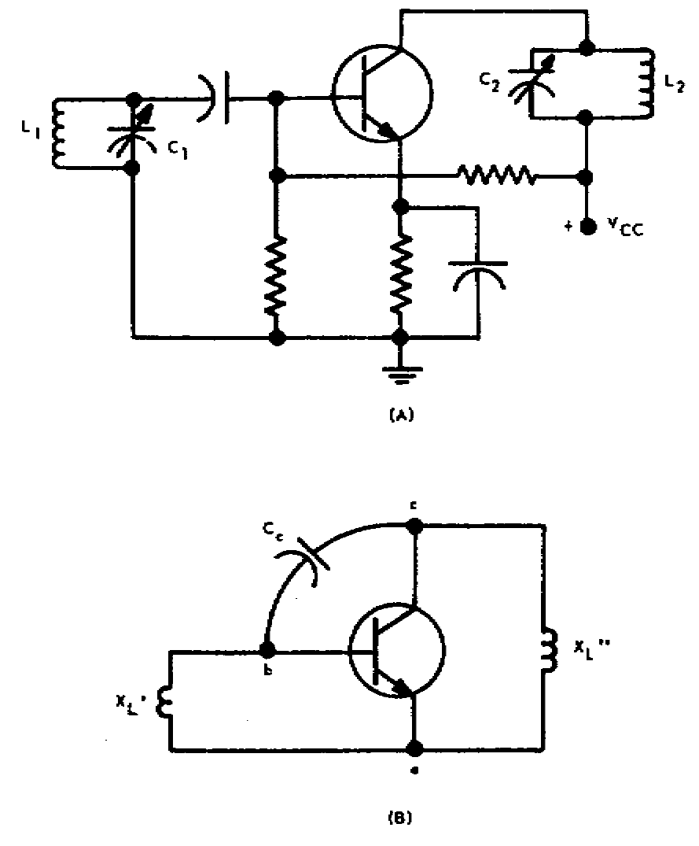

Figure 2-7. Tuned-collector tuned-base oscillator.

collector-to-base interelectrode capacitance CC, as shown. Now compare the circuit in B of figure 2-7 with that of the Hartley oscillator in B of figure 2-6. They are identical. Thus the tuned-collector tuned-base oscillator operates to produce a sine-wave signal by virtue of the fact it is essentially a Hartley arrangement.

(2) Now you can appreciate why an RF or IF amplifier may break into oscillation. If CC is sufficient in value (or an additional capacitor is connected from collector to base), the generation of a sinusoidal signal of a given frequency will result. The generated frequency will necessarily be less than the resonant frequency of both the input and output tanks since both tanks must appear inductive to the signal.

d. Colpitts. Instead of connecting the emitter to the inductance of a tank circuit as is done for the Hartley, in the Colpitts oscillator the emitter is connected between two capacitors. This arrangement constitutes the distinguishing difference between a Colpitts and a Hartley oscillator.

e. Crystal-Controlled Oscillators. A piezoelectric crystal can behave as a high-Q circuit. The electrical equivalent network for such a crystal is illustrated in A of figure 2-8. This network will have a series resonant point when XL = XC1, and a parallel resonant point when XL = XC1 + XC2 Part B of figure 2-8 depicts a typical impedance-versus-frequency plot. Observe that at series resonance the crystal is practically a short circuit.

19

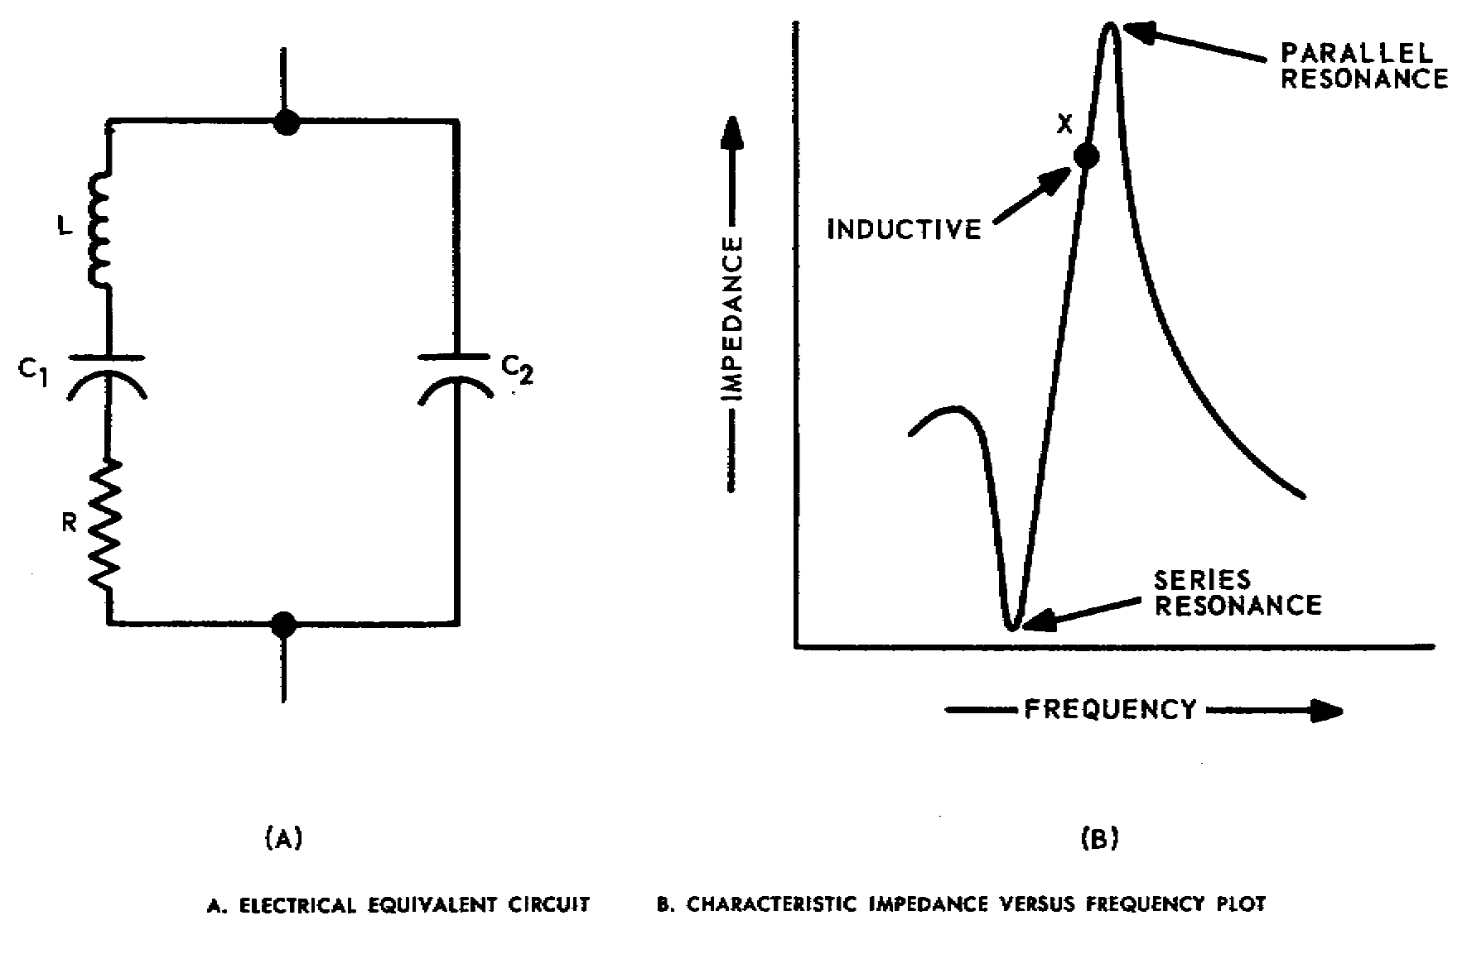

Figure 2-8. Piezoelectric crystal.

(1) One type of crystal-controlled oscillator that uses the crystal's series resonant feature for frequency determination is shown in A of figure 2-9. For variety a PNP transistor is shown, so biases are negative. This shunt-fed crystal-controlled oscillator is basically a tickler-coil type. Regenerative feedback is obtained by transformer action. The collector tank is tuned to the series resonant frequency of the crystal. Because the crystal is very selective, it greatly improves the frequency stability of the signal generated.

(2) Another crystal-controlled oscillator is shown in B of figure 2-8. You should recognize it as a Colpitts type. The inductance required to resonate with C1 and C2 is provided by the crystal.

(3) These are but two of a wide variety of ways to use crystals for frequency control of oscillators. The main advantage of crystals is their stabilizing influence.

20

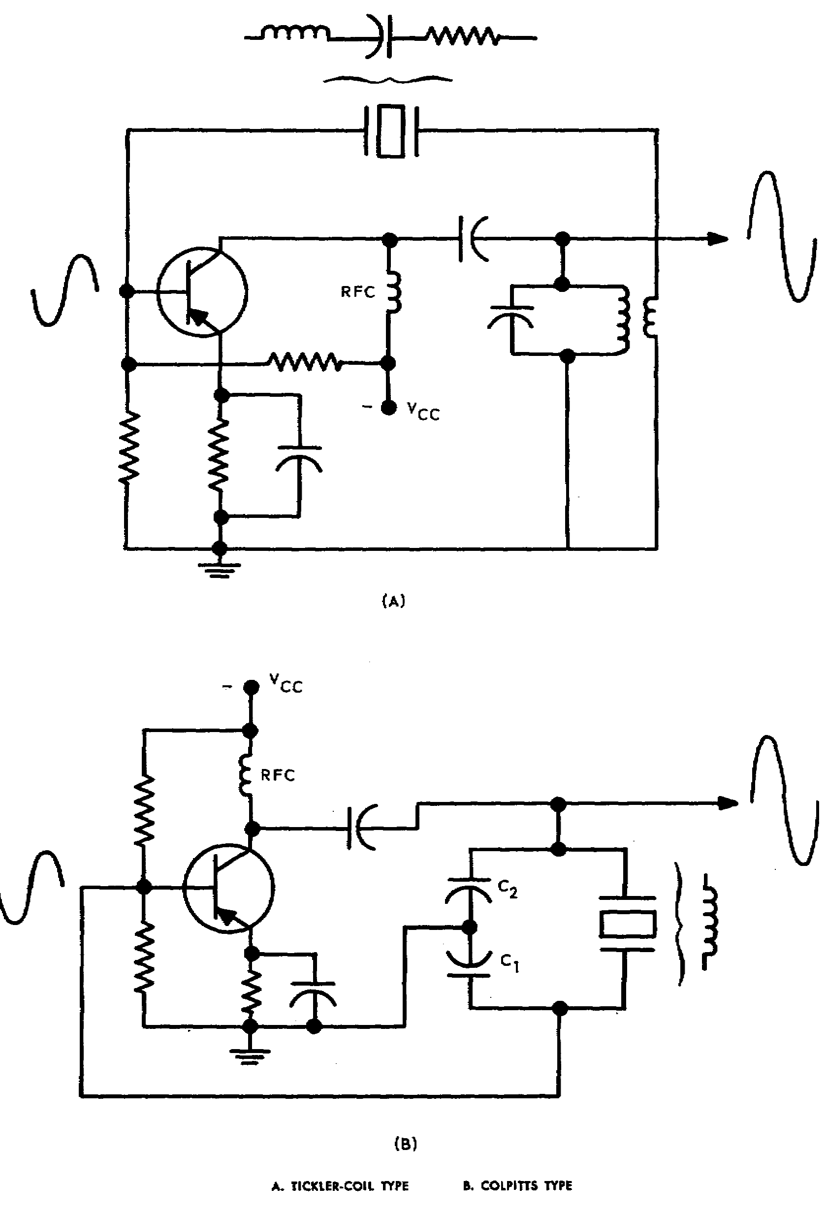

Figure 2-9. Crystal-controlled LC oscillators.

21

LESSON EXERCISES

In each of the following exercises, select the ONE answer that BEST completes the statement or answers the question. Indicate your solution by circling the letter opposite the correct answers in the subcourse booklet.

1. Assume that the FM receiver shown in figure 153 of TM 11-668 has a first IF of 4.3 MHz and a second IF of 455 kHz. If the receiver is tuned to a station with a carrier frequency of 35 MHz, the first and second oscillators may have frequencies that are, respectively,

a. 4.3 MHz and 455 kHz. c. 30.7 MHz and 4.755 MHz.

b. 4.755 MHz and 455 kHz. d. 39.3 MHz and 39.455 kHz.

2. Since the mixing circuits in a radio receiver must have nonlinear characteristic responses, the devices that may be used as mixers include

a. pentode electron tubes, crystal diodes, and transformers.

b. triode electron tubes, germanium crystals, and transformers.

c. diode electron tubes, silicon crystals, and resistor networks.

d. diode electron tubes, silicon crystals, and pentode electron tubes.

3. Assume that the mixer tube in an FM receiver has a transconductance of 4,000 micromhos and a plate load impedance of 2,000 ohms at the IF. If the input signal to the mixer is 320 microvolts and maximum conversion transconductance is reached, the conversion gain will be

a. less than 2. c. between 5 and 10.

b. between 2 and 5. d. greater than 10.

4. The local oscillator of a receiver that is designed to receive signals in the FM broadcast band (88 MHz to 108 MHz) has a frequency higher than that of the incoming signal. To prevent FM signals within this band from being introduced as an interfering image signal, the minimum IF should be approximately

a. 10.7 MHz. NOTE: Image frequency = Incoming
signal + (2 x IF).
b. 20.0 MHz.

c. 44.0 MHz.

d. 98.5 MHz.

22

5. In designing an FM receiver it is found that a weak signal is lost as a result of a strong signal from an adjacent channel. The degree of this oscillator frequency pulling can be reduced by

a. increasing the coupling of the RF amplifier.

b. isolating the mixer from the oscillator.

c. reducing the intermediate frequency.

d. applying AVC to the mixer grid.

6. Assume that the FM receiver whose circuit is shown in figure 152 of TM 11-668 has a frequency range of 20 to 30 MHz, but satisfactory reception is obtained only in the frequency range of 20 to 25 MHz because of improper tracking. Improved reception can be achieved by adjusting

a. capacitor C29.

b. capacitors C27 and C28.

c. the capacitors located in T4.

d. the capacitors located in T1, T2, and T3.

7. When the mixer and oscillator in a superheterodyne receiver are tuned so that a constant frequency difference is maintained between them, the oscillator is said to be

a. pulling. c. radiating.

b. tracking. d. converting.

8. The function of a padder in a radio receiver is to

a. cause the RF signal to lock in with the oscillator.

b. increase the response of the mixer to high frequencies.

c. reduce the shot effect and partition noise in the receiver.

d. provide a tracking adjustment at the low end of the receiver band.

9. The VHF band nominally extends from 30 MHz to 300 MHz. The types of frequency transforming devices that may be used in an FM receiver designed to operate around 300 MHz include the

a. diode mixer, triode mixer, and pentode mixer.

b. diode mixer, push-push triode mixer, and crystal mixer.

c. pentagrid mixer, crystal mixer, and pentagrid converter.

d. push-push triode mixer, pentagrid converter, and pentagrid mixer.

23

10. The various mixer circuits used in frequency conversion in FM receivers offer varying degrees of noise, gain, and simplicity of construction. Because of their similarity in construction, a minimum number of additional circuit elements is required when interchanging the

a. pentagrid converter and pentagrid mixer.

b. triode mixer and dual-triode mixer.

c. diode mixer and crystal mixer.

d. diode mixer and triode mixer.

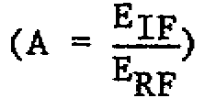
11. The type of mixer that is capable of producing the greatest amount of
conversion gain is the

a. diode mixer. c. pentode mixer.

b. triode mixer. d. pentagrid mixer.

12. Frequency conversion in a superheterodyne receiver may be accomplished by either a mixer or a converter. In contrast to a mixer that is used to produce the IF, a converter is characterized by its

a. use of a single electron tube.

b. high gain at high frequencies.

c. use of an electron tube with five grids.

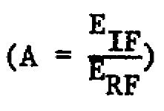
d. resistance to pulling with a strong input signal.

13. The mixer that provides the least amount of conversion gain
is the

a. triode mixer. c. crystal mixer.

b. pentode mixer. d. pentagrid converter.

14. The local oscillators in most VHF receivers utilize some form of a Colpitts oscillator because the Colpitts type of oscillator circuit

a. has a broad tuning range.

b. is similar to a crystal oscillator circuit.

c. is immune to supply voltage variations.

d. generates a frequency that is not affected by tube reactances.

15. Assume that a crystal oscillator is to be used as the local oscillator for the first mixer in a double-conversion FM receiver. The characteristics of the crystal oscillator must include

24

a. wide tuning range, large number of harmonics, and low output at frequencies below desired frequency.

b. large number of harmonics, low output at frequencies below desired frequency, and high stability of operation.

c. low output at frequencies below desired frequency, high stability of operation, and wide tuning range.

d. high stability of operation, wide tuning range, and large number of harmonics.

16. Compared with the harmonic oscillator circuit, the overtone oscillator differs in its

a. need for a specially designed crystal, use of frequency-selective feedback, and range of operating frequencies.

b. use of frequency-selective feedback, range of operating frequencies, and negligible number of subharmonic frequencies.

c. range of operating frequencies, negligible number of subharmonic frequencies, and need for a specially designed crystal.

d. negligible number of subharmonic frequencies, need for a specially designed crystal, and use of frequency-selective feedback.

17. If a transistor is being used as a converter, it must be operated on the curved portion of its dynamic characteristic curve. Operation at this point is required in order to

a. produce four major frequencies in the output.

b. incorporate the filtering action of the collector circuit.

c. establish the required low input and output resistances.

d. use the internal feedback for neutralizing the generated frequency.

18. In the mixer circuit shown in figure 2-3, what frequencies appear in the collector circuit that are not coupled through the transformer to the following stage?

a. 500 kHz, 1 MHz, and 1.5 MHz

b. 500 kHz, 1 MHz, and 2.5 MHz

c. 500 kHz, 1.5 MHz, and 2.5 MHz

d. 1 MHz, 1.5 MHz, and 2.5 MHz

19. Stability of the tickler-coil oscillator shown in figure 2-5 is based on several factors incorporated in the circuit. The bias stability and frequency stability of the circuit are determined by the

25

a. phase inversion of the collector tank circuit and base-leak bias, respectively.

b. class of transistor operation and the Q of the tank circuit, respectively.

c. Q of the tank circuit and the class of transistor operation, respectively.

d. base-leak bias and the Q of the tank circuit, respectively.

20. The tuned-collector tuned-base oscillator illustrated in figure 2-7 is basically a Hartley oscillator arrangement. A comparison between the output frequency and the resonant frequencies of the tank circuits shows that the output frequency is

a. lower than the resonant frequencies of the two tank circuits.

b. higher than the resonant frequencies of the two tank circuits.

c. equal to the resonant frequency of the output tank, but lower than that of the input tank.

d. equal to the resonant frequency of the input tank, but higher than that of the output tank.

CHECK YOUR ANSWERS WITH LESSON 2 SOLUTION SHEET PAGES 56, 57, and 58.

26

LESSON 3

IF AMPLIFIERS, LIMITERS, AND DETECTORS

SCOPE Operation of IF amplifiers; design of IF stages to achieve the desired gain, response, and selectivity; use of limiters and detectors to reduce noise and convert the signal into audio variations.

CREDIT HOURS 2

TEXT ASSIGNMENT TM 11-668, para 72-81;
Attached Memorandum, para 3-1 thru 3-5

MATERIALS REQUIRED None

SUGGESTIONS a. Read the assignment in TM 11-668 before you read the attached memorandum.

b. Note: TM 11-668, page 159, figure 139. The wave in the lower left side of the diagram does not represent the IF signal itself. The amplitude of this wave shows the amount of frequency shift of the IF signal. The actual IF signal is constant in amplitude but it varies in frequency.

LESSON OBJECTIVES

When you have completed this lesson, you will be able to:

1. Determine the response characteristics of transformer coupled amplifiers.

2. Describe the effects of loading tuned circuits in IF amplifier stages.

3. Identify and analyze the detectors and discriminators used in FM receivers.

ATTACHED MEMORANDUM

3-1. IF AMPLIFIERS AND LIMITERS

The circuits employed as IF stages of FM receivers are similar to the ones used in RF amplifiers (para 1-1 through 1-3). The same coupling arrangements are used for both IF and RF amplifiers. The major difference lies in the component values used for the two circuits. The IF amplifiers operate about a center frequency that is considerably lower than the frequency applied to

27

the RF stages, hence, larger valued components are needed in the IF stages. The last IF stage is generally followed by a limiter stage. This limiter is essentially another IF amplifier arranged so that it limits both positive and negative outputs.

3-2. TRANSISTORIZED IF AMPLIFIER

A typical circuit for a transistorized IF amplifier is shown in figure 3-1. The circuit's collector current is determined by a voltage divider on the base and a large resistance in the emitter lead. The input and output signals are coupled by means of tuned transformers. The collector of the transistor is connected to a tap on the output transformer to provide proper matching for the transistor and also to make performance of the stage relatively independent of variations between transistors of the same type. The gain of a transistorized IF amplifier decreases if the emitter current decreases. This current property of the transistor can be used to control the gain of the IF amplifier so that weak signals and strong signals produce the same output power. Typical circuits for changing the gain of an IF amplifier in accordance with the strength of the received signal are explained in lesson 4.

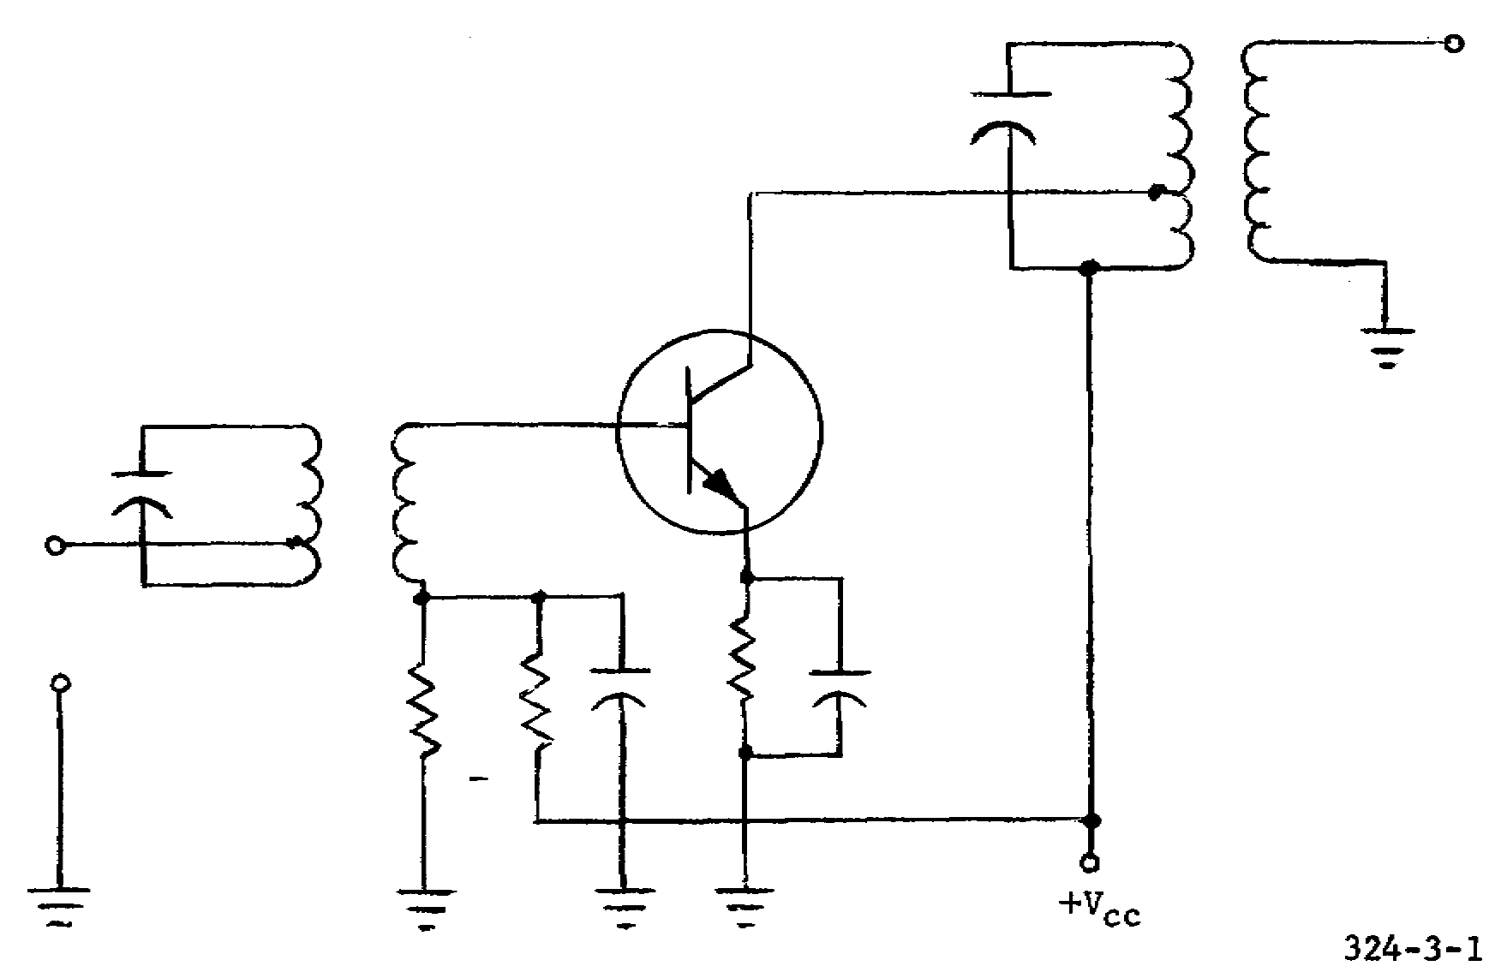

Figure 3-1. Transistorized IF amplifier.

3-3. FOUR-STAGE IF AMPLIFIER

The circuit shown in figure 3-2 uses synchronous, single-tuned transformers for interstage coupling. Excellent bias stability is attained by connecting the base of each transistor to dc ground and using separate supplies for the collectors and emitters.

28

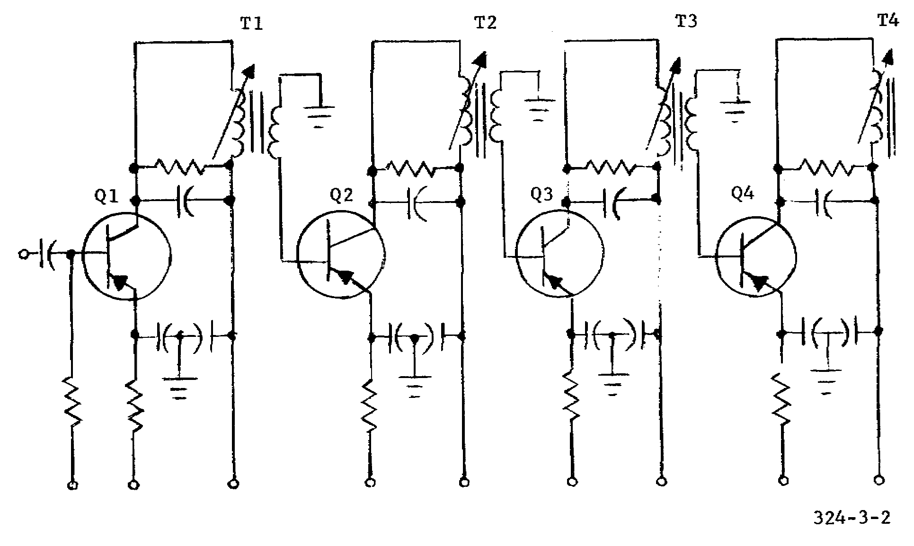

Figure 3-2. Four-stage IF amplifier.

a. Resistive Loading. Resistive loading of the tank circuits increases the bandwidth while simultaneously reducing the possibility of oscillation. This increase in bandwidth is accomplished at the expense of gain, but it has the advantage of being noncritical and eliminates the need of neutralizing circuits. Furthermore, resistive loading reduces bandwidth variation as a function of temperature and transistor operating points.

b. Capacitive Loading. Capacitive loading of the tank circuit is used to further reduce the sensitivity to temperature and bias drifts.

3-4. DISCRIMINATORS

a. General. A discriminator in an FM receiver performs the same general function as a detector in an AM receiver--that is, deriving an audio signal from the IF. The electron-tube diodes in the discriminator and detector circuits described in TM 11-668 can be replaced by solid-state diodes without making any substantial changes. The names and principles of operation remain the same regardless of the type of diode used. The discriminator transfer characteristics for the electron-tube and solid-state diodes are the same. If the frequency shift of the incoming IF signal exceeds the linear portions of the S-shaped transfer characteristic curve, the output becomes distorted in almost the same manner as when the receiver is detuned.

b. Transistorized Discriminator. Figure 3-3 shows a transistorized version of an IF stage and a discriminator. Amplifier Q1 amplifies the IF signal to be applied to the discriminator. Resistor R1 is the emitter-swamping resistor, and capacitor C1 is an IF bypass. Capacitor C2 and the primary of transformer

29

T1 form a parallel resonant circuit for the IF signal that is coupled through the transformer to the discriminator. Capacitor C3 couples the IF signal to the secondary of transformer T1 for phase shift comparison. The IF signal, coupled across capacitor C3, is developed across coil L1. Capacitor C4 and the secondary of transformer T1 form a resonant circuit for the IF signal coupled through the transformer. The top half of transformer T1 secondary, diode CR1, coil L1, load resistor R3, and filter capacitor C5 form one half of the comparison network. The bottom half of transformer T1 secondary, diode CR2, coil L1, load resistor R3, and filter capacitor C6 form the second half of the comparison network. The audio output of the discriminator circuit is taken from the top of capacitor C5 and the bottom of capacitor C6. The audio output is coupled through capacitor C7 to the primary of transformer T2. The audio signal, coupled through transformer T2, is applied to the following stage.

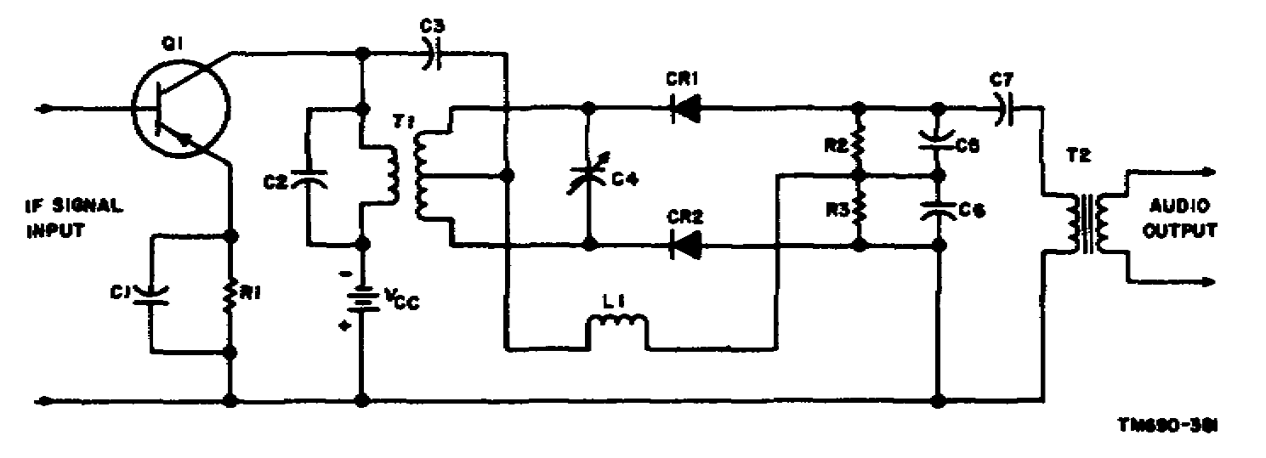

Figure 3-3. Discriminator.

3-5. SLOPE DETECTOR

a. Purpose. A slope detector converts the frequency changes of a carrier signal into amplitude changes. The amplitude changes can then be detected by an AM diode detector or an AM transistor detector. The input and output waveforms of a slope detector and an AM diode detector are shown in figure 3-4. The IF signal with frequency deviations is applied to slope detector Q1. The output of slope detector Q1, the IF signal with amplitude and frequency deviations, is applied to diode detector CR1. The resultant output is an audio signal which is equivalent to the frequency deviations of the IF input signal.

b. Operation. The IF signal coupled through transformer T1 is applied to the base circuit. The resonant circuit, consisting of coil L1 and capacitor C2 (tuned slightly off the carrier frequency), develops a large amount of IF signal when the frequency deviation is near the resonant frequency. As the frequency deviation of the IF signal becomes lower than the resonant frequency of the resonant circuit, a smaller amount of IF signal is developed. A large amount of IF signal added to the bias voltage developed across resistor R1 increases the emitter-base bias, and a small amount of IF signal is developed. A large amount of IF signal added to the bias voltage developed across resistor R1 increases the emitter-base bias. The emitter-base bias is therefore increasing and decreasing as the frequency of the IF signal increases and decreases, respectively. Since the bias of slope detector Q1 changes at the frequency deviation rate, the gain also changes at the frequency deviation rate. Thus, the output of the slope detector is an IF signal that is changing

30

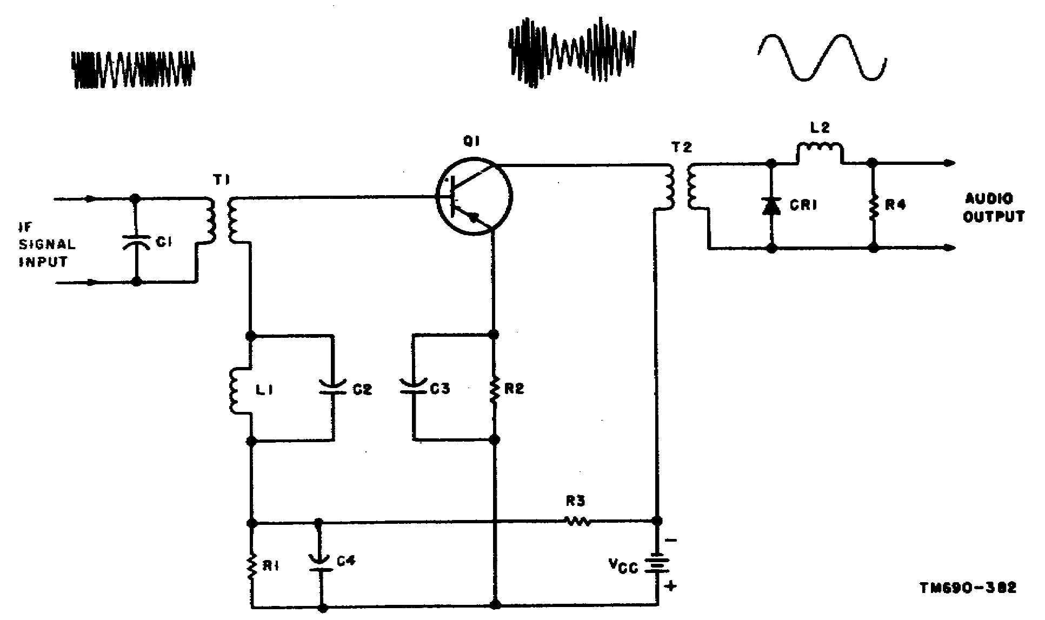

Figure 3-4. Slope detector.

in amplitude and frequency. The IF signal applied to diode detector CR1 is rectified, filtered by coil L2, and developed across resistor R4. The output of the current output-type diode detector is an audio signal.

c. Component Functions. Capacitor C1 and the primary of transformer T1 form a parallel resonant circuit for the IF signal that is coupled through the transformer to the base circuit of slope detector Q1. Capacitor C2 and coil L1 form a parallel resonant circuit for a frequency slightly higher than the maximum frequency deviation of the IF signal. Resistor R1 is the base-emitter bias resistor, and resistor R3 is a voltage-dropping resistor. Resistor R2 is the emitter-swamping resistor, and capacitors C3 and C4 are bypass capacitors for the IF signal. Transformer T2 is an output coupling transformer for slope detector Q1. Diode CR1 is the AM detector, resistor R4 is a load resistor, and coil L2 is a filter.

LESSON EXERCISES

In each of the following exercises, select the ONE answer that BEST completes the statement or answers the question. Indicate your solution by circling the letter opposite the correct answers in the subcourse booklet.

31

1. Assume that the center frequency of the IF signal in an FM receiver is 9.1 MHz. If one of the IF tuned circuits has a Q of 100, it will pass a band of frequencies 91 kHz wide. If the circuit is adjusted to pass efficiently a band of frequencies 150 kHz wide, it must have a Q of approximately

a. 10. c. 60.

b. 30. d. 140.

SITUATION

Figure 153 of TM 11-668 is the schematic diagram of a military double-conversion superheterodyne FM receiver. Assume that: Bandpass of the tuned circuits = 150 kHz (that is, the response is 3 db down at 75 kHz to either side of the center frequency).

Q of primary = Q of secondary (transformer T2)

1st IF = 4.3 MHz

2d IF = 455 kHz

Exercises 2 and 3 are based on this situation.

2. Assume that the receiver in figure 153 is receiving a signal that introduces significant IF side frequencies of 380 kHz and 430 kHz to the second IF strip. Compared with the signal power for these frequencies at the plate of V5, the signal power at the grid of V9 will be reduced by approximately

a. 6 db. c. 24 db.

b. 18 db. d. 32 db.

3. The response characteristic of a transformer-coupled amplifier depends on the Q of the circuit and the degree of coupling between the transformer windings. The coefficient of coupling required to provide the desired 150-kHz bandpass through transformer T2 is approximately

a. 0.015. c. 0.035.

b. 0.025. d. 0.045.

4. Assume that an FM receiver with an IF of 4.7 MHz is tuned to a station with a carrier frequency of 108 MHz and a frequency deviation of 75 kHz. An oscilloscope is to be connected across the output of the final IF amplifier to determine the frequency response of the entire IF section. If the receiver has an ideal response to this signal, the oscilloscope presentation will appear

a. high at 4.7 MHz, and gradually dropping to zero at 4.625 MHz and 4.775 MHz.

b. high at approximately 4.650 MHz and 4.735 MHz, with a slight dip at 4.700 MHz.

32

c. sharply peaked at 4.7 MHz, and dropping off rapidly at frequencies above and below.

d. constantly high between 4.625 MHz and 4.775 MHz, and zero below 4.625 MHz and above 4.775 MHz.

5. Stagger tuning is often employed in IF stages of FM receivers to

a. broaden the response to sideband frequencies and reduce the tendency of the IF's to oscillate.

b. increase the receiver tuning range and broaden the response to sideband frequencies.

c. reduce the tendency of the IF's to oscillate and reduce the amount of phase distortion.

d. reduce the amount of phase distortion and increase the receiver tuning range.

6. Ideally, the IF amplifier section of an FM receiver will be designed to produce high gain over a fairly wide band of frequencies and good attenuation of the adjacent channel signals. An effective means of providing adjacent-channel rejection is to use

a. stagger-tuned IF amplifiers.

b. overcoupled IF transformers.

c. resistance-coupled amplifiers preceded by a bandpass filter.

d. critically coupled transformers with double conversion.

7. A transformer-coupled pentode IF stage tends to become unstable and less selective at high frequencies because of the residual capacitance between the plate and grid of the tube. This tendency may be reduced by

a. increasing the gain of the stage.

b. replacing the tube with a low-gain triode.

c. connecting four capacitors in a bridge circuit between the grid and ground.

d. selecting a capacitor of proper value as a bypass for both screen and plate circuits.

8. In high-gain IF systems, it is usually necessary to isolate the input circuit from the output circuit in order to prevent oscillations. If the IF system has extremely high gain and wide bandpass requirements, the isolation can be accomplished with a minimum of added noise by using

a. stray capacitance to tune the plate circuits of the IF stages.

b. transformers with a high ratio of inductance to capacitance.

33

c. a frequency doubler stage in the IF system.

d. an additional frequency converter stage.

9. The primary function of a limiter in an FM receiver is to

a. increase the selectivity of the receiver.

b. remove amplitude variations from the IF signal.

c. provide an AVC voltage for the preceding stages.

d. restrict the frequency deviation to keep signal within bandpass limits.

10. The requirements of a limiter stage used in an FM receiver include

a. large input signal, low plate and screen voltage, and sharp cutoff tube.

b. large input signal, sharp cutoff tube, and high plate and screen voltages.

c. sharp cutoff tube, low plate and screen voltage, and high gain.

d. low plate and screen voltage, low gain, and remote cutoff tube.

11. The operating characteristic of a typical discriminator is shown in figure 3-5. If this discriminator is to produce an output that is free of distortion, the signal bandwidth should not exceed

a. 40 kHz. c. 120 kHz.

b. 80 kHz. d. 200 kHz.

12. Assume that an oscilloscope is being used to determine the nature of the voltage at point X with respect to ground in the circuit shown in figure 3-6. Analysis shows that during normal operation the voltage is

a. zero c. negative dc.

b. positive dc. d. audio-frequency ac.

13. The ratio detector shown in figure 3-6 has a network that serves to eliminate AM noise impulses from the signal. The components that make up this network are

a. capacitor C3 and capacitor C4.

b. capacitor C5 and resistor R2.

c. tube V1 and tube V2.

d. tube V1 and coil L3.

34

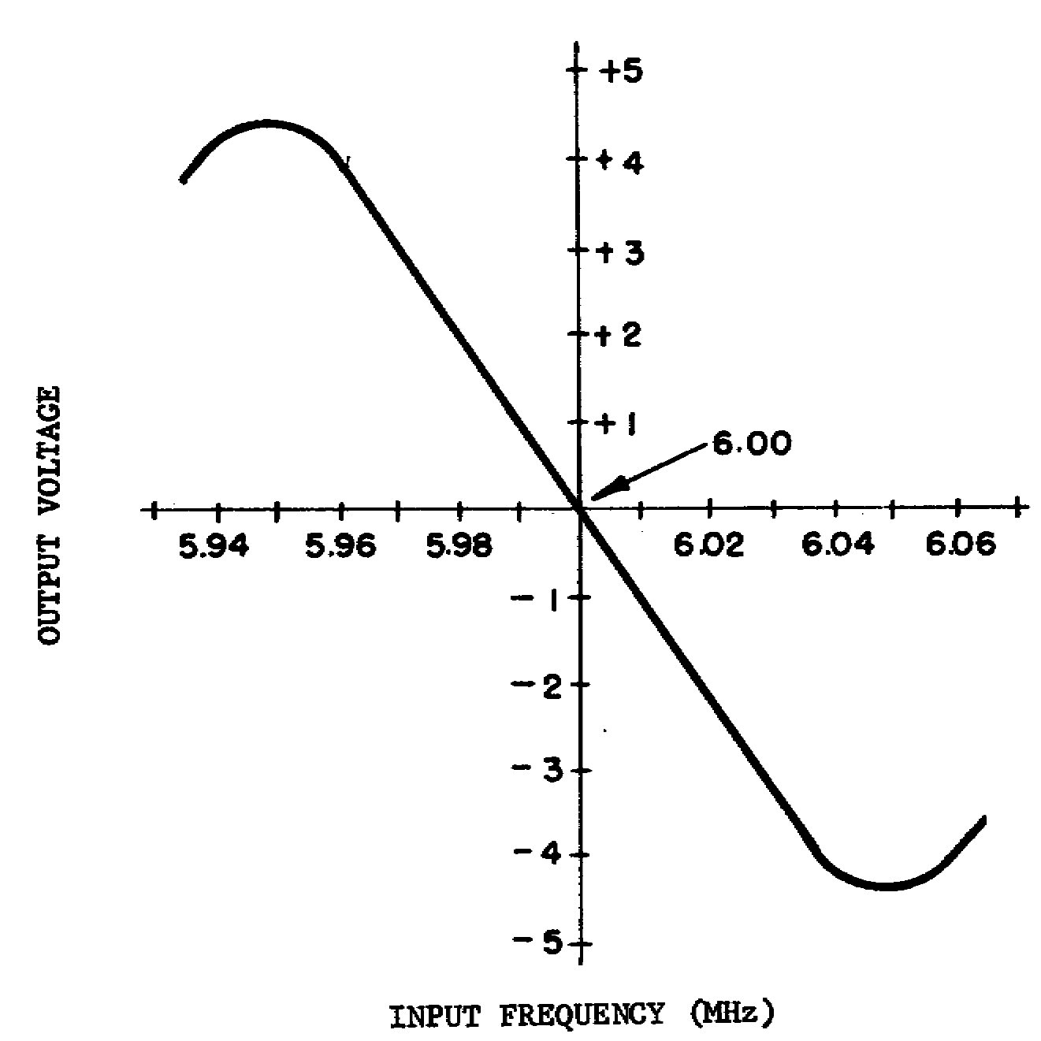

Figure 3-5. Typical operating characteristic of discriminator circuit.

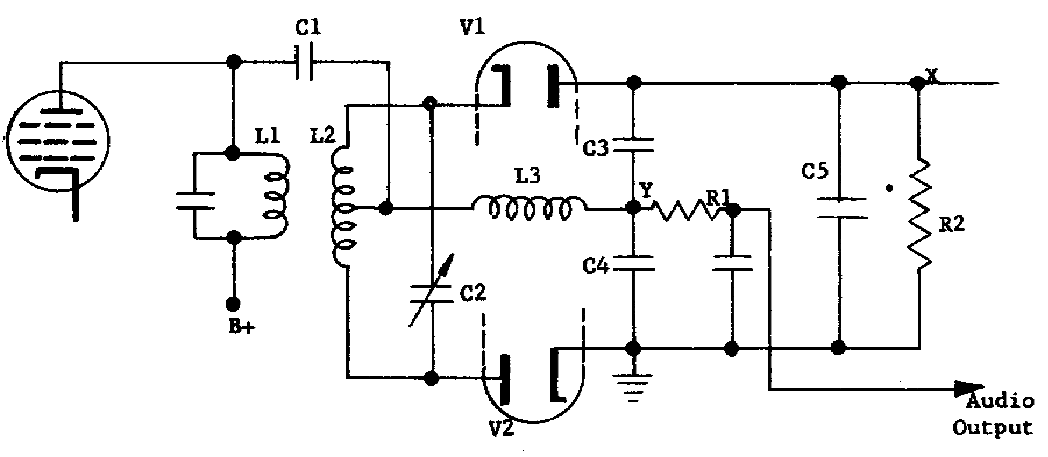

Figure 3-6. Ratio detector.

35

14. Compared with the ratio detector, the phase discriminator has the advantage of

a. having greater response to AM.

b. requiring no limiter stage.

c. having greater sensitivity.

d. being easier to align.

15. In selecting a demodulating circuit for an FM receiver, the type that is recommended to provide the greatest discrimination against cochannel (signals within the same channel) interference is the

a. ratio detector.

b. phase discriminator.

c. cycle-counting detector.

d. locked-oscillator detector.

16. The type of FM demodulating circuit that has the simplest alignment procedure is the

a. locked-oscillator detector.

b. gated-beam-tube detector.

c. cycle-counting detector.

d. ratio detector.

17. Good bias stability is one of the requirements that must be fulfilled in IF amplifier circuits to obtain the desired sensitivity. One method used to obtain the needed stability is to

a. overcouple the IF transformers.

b. use resistors to load the tuned circuits.

c. ground the base leads and use separate power supplies for the emitters and collectors.

d. install common-emitter configurations and incorporate neutralizing circuits.

18. Resistive loading of the tuned circuits of IF stages tends to increase the

a. sensitivity of the amplifiers to temperature changes.

b. possibility of amplifier oscillation.

36

c. bandwidth of the IF stages.

d. gains of the IF stages.

19. The circuit shown in figure 3-7 recovers the intelligence from the modulated signal. This circuit is called a

a. modified phase discriminator.

b. double-tuned discriminator.

c. slope detector.

d. ratio detector.

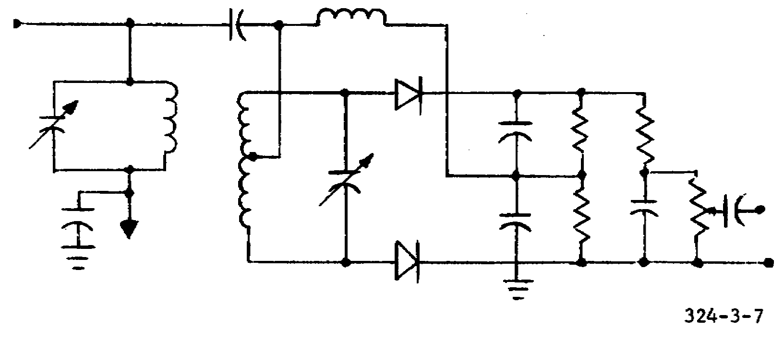

Figure 3-7. Signal recovery circuit.

20. A slope detector is designed so that the gain of the circuit changes in accordance with the

a. amplitude changes of the IF signal.

b. frequency changes of the IF lower sideband.

c. frequency changes of the IF upper sideband.

d. frequency deviation rate of the IF signal.

CHECK YOUR ANSWERS WITH LESSON 3 SOLUTION SHEET PAGES 58 AND 59.

37

LESSON 4

SPECIAL CIRCUITS AND ALIGNMENT

SCOPE Purpose and operation of squelch circuits; general alignment procedures for FM receivers; typical equipment in military use.

CREDIT HOURS 2

TEXT ASSIGNMENT TM 11-668, para 82-99;
Attached Memorandum, para 4-1 thru 4-13

MATERIALS REQUIRED None

SUGGESTIONS Read the assignment in TM 11-668 before you read the attached memorandum.

LESSON OBJECTIVES

When you have completed this lesson, you will be able to:

1. Identify and analyze the squelch circuits used in FM receivers.

2. Align an FM receiver by the visual and meter methods.

3. Analyze circuit operation and to troubleshoot both electron tube and transistorized FM receivers.

ATTACHED MEMORANDUM

Section I. SPECIAL CIRCUITS AND ALIGNMENT

4-1. AUTOMATIC GAIN CONTROL (AGC)

Tuned amplifiers are used extensively in radio and television receivers as RF and IF amplifiers. In these applications, it is often desired to automatically vary the gain of the amplifier in accordance with the strength of the RF signal carrier received at the antenna; that is, lower gain is required for strong signals and higher gain is required for weak signals. One component of the output of the second detector of a receiver is a dc voltage that is directly proportional to the strength of the RF signal carrier received. It is this dc component that can be used to vary the gain of the tuned amplifiers.

a. Dc Emitter Current Control. The power gain of the common-emitter amplifier shown in A of figure 4-1 is controlled by feeding the AGC voltage to the base of the amplifier to vary the dc emitter current.

38

(1) In this case, the tuned amplifier is also operating as a dc amplifier to increase the dc current output of the second detector. If the dc current output of the second detector is sufficiently large, the dc emitter current of the tuned amplifier may be varied directly.

(2) In the circuit, resistors R1 and R4 form a voltage divider and establish the no signal negative (forward) bias on the base. The AGC voltage input from the second detector is positive with respect to ground and is fed to the base through dropping resistor R2. When the dc output of the second detector increases (because of a high carrier signal input to the detector), the positive dc voltage fed to the base of transistor Q1 through dropping resistor R2 reduces the net negative (forward) bias on the base and decreases the emitter current. The gain of the amplifier is also decreased.
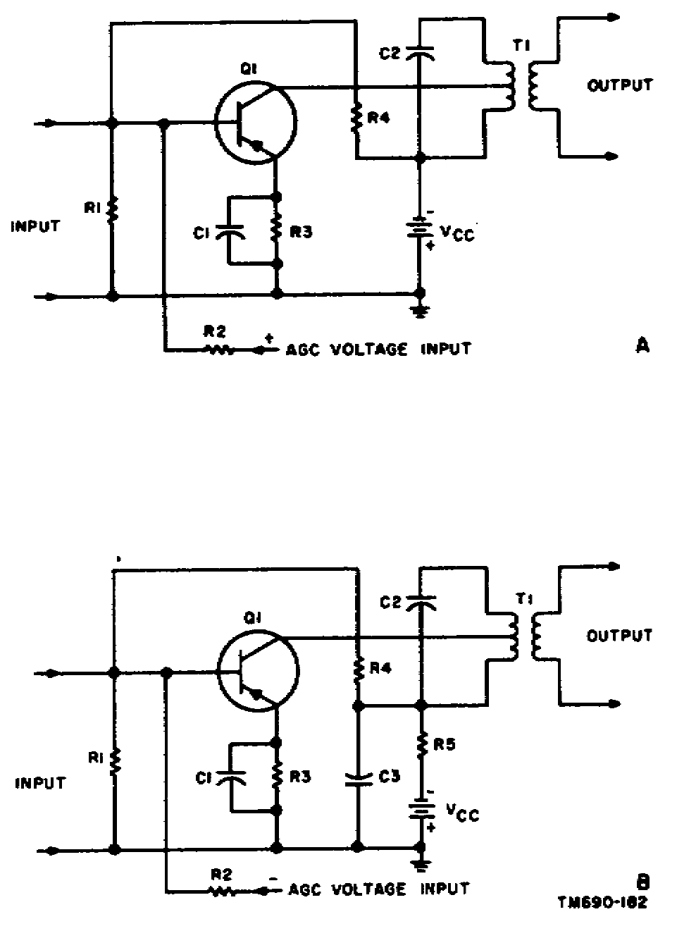

Figure 4-1. Common-emitter amplifier with AGC.

When the dc output of the second detector decreases, the net forward bias of Q1 increases and increases the emitter current. The gain of the amplifier increases.

(3) Resistor R3, ac bypassed by capacitor C1, is the emitter-swamping resistor. Capacitor C2 and the primary of transformer T1 form a parallel tuned circuit to develop the collector input signal. Transformer T1 matches the collector output of Q1 to the input of the following stage. The primary of T1 is tapped to obtain the desired amplifier selectivity (Qo).

b. Dc Collector Voltage Control. The power gain of the common-emitter amplifier shown in B of figure 4-1 is controlled by feeding the AGC voltage to the base of the amplifier to vary the dc emitter current which, in turn, varies the dc collector voltage. The dc collector voltage is varied by passing the collector current through resistor R5. To be effective, resistor R5 must be 10,000 ohms or higher in value.

(1) In this case, the tuned amplifier is also operating as a dc amplifier to increase the dc output voltage of the second detector. If the dc voltage output of the second detector is sufficiently large, the dc collector voltage of the tuned amplifier may be varied directly.

39

(2) In the circuit shown in B of figure 4-1, resistors R1 and R4 form a voltage divider and establish the no-signal negative (forward) bias on the base. The AGC voltage from the second detector is negative with respect to ground and is fed to the base through dropping resistor R2. When the dc output of the second detector increases (because of a high carrier signal input to the detector), the negative dc voltage fed to the base of transistor Q1 through dropping resistor R2 increases the net negative (forward) bias on the base and increases the emitter current and, therefore, the collector current. The flow of increased collector current through resistor R5 reduces the collector voltage. The gain of the amplifier is also reduced. When the dc output of the second detector decreases, the net forward bias of transistor Q1 decreases. Emitter and collector current decreases; collector voltage increases, and the gain of the amplifier increases.

(3) Capacitor C3 ac-bypasses resistor R5 to ground. Correspondingly referenced circuit elements in both A and B of figure 4-1 perform the same circuit function.

4-2. SQUELCH

The limiter and discriminator-derived squelch voltages discussed in TM 11-668 are developed through the use of either the noise or carrier signals. When either the noise or the carrier signals are used to develop the squelch voltage, the type of squelch is referred to as old. A third method is also used in some FM transmitters and receivers, which is referred to as either tone or new. The tone squelch is derived from a 150-Hz tone. This tone modulates the carrier signal in the transmitter and is transmitted along with the intelligence. The receiver squelch circuit recovers the 150-Hz tone and develops the squelch voltage for use in the receiver.

4-3. THE VOLTMETER IN RECEIVER ALIGNMENT

a. The proper alignment of a radio receiver requires a means of measuring the output when a known signal voltage is applied at the input. The signal is usually supplied by a signal generator while the output is measured by an oscilloscope, output meter, or voltmeter. If a voltmeter is used, its input resistance must be greater than the resistance of the circuit to be measured, or the readings will be inaccurate.

b. The input resistance of a voltmeter is determined by a number of resistors, or multipliers, connected in series with the meter movement (galvanometer). Adding multipliers makes it possible to extend the range of the voltmeter. The sensitivity of a meter is determined by dividing the total series resistance by the full-scale reading in volts. Thus, if the total series resistance of a meter is 50,000 ohms for the 50-volt scale, the meter sensitivity is 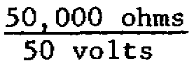 = 1,000 ohms per volt. In general, 50 volts a 1,000-ohm-per-volt meter is satisfactory, but more accurate measurements in high-resistance circuits require the use of a meter with greater sensitivity, such as the 20,000-ohm-per-volt meter or the vacuum-tube voltmeter (VTVM).

40

c. For an illustration of the effect of the meter sensitivity on the accuracy of voltage readings in high-resistance circuits, refer to figure 4-2. Normally, the two series resistors (R1 and R2) across the voltage source would divide the voltage in the ratio of 1-to-2, causing the voltmeter to read 50 volts (A of fig. 4-2). However, the voltmeter appears as a 50K-ohm resistor in parallel with R2. This effectively reduces the equivalent resistance of R2 and causes the voltage to be divided in the ratio of 1-to-l (B of fig. 4-2). The voltmeter will now read 37.5 volts. It should be apparent after studying the diagram that, compared with the meter resistance, the higher the resistance in the circuit, the greater the "loading' effect of the voltmeter. Sometimes the loading effects of a voltmeter can be reduced by switching the meter to the next higher range because the addition of a multiplier increases the input resistance of the meter.

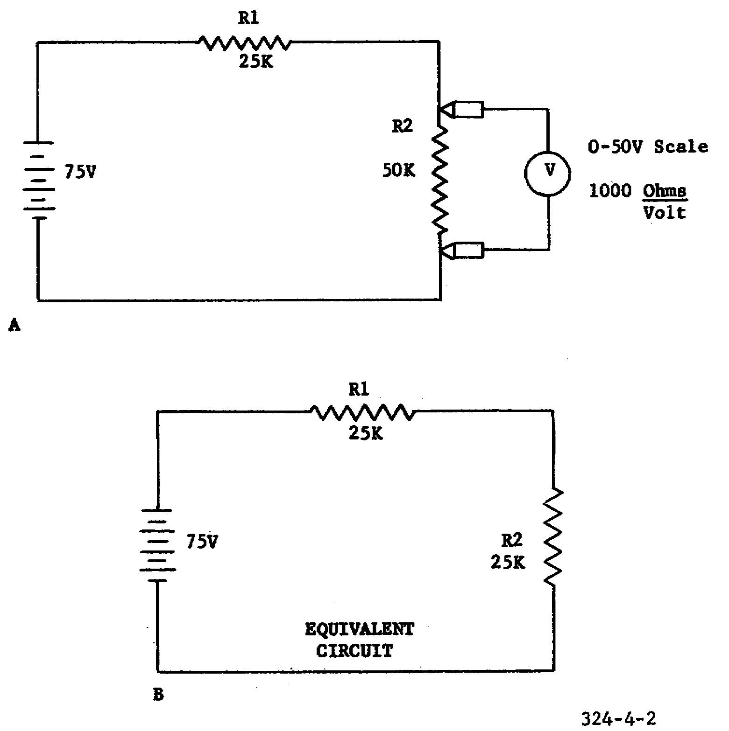

Figure 4-2. Loading effects of a voltmeter.

d. Although a 20,000-ohm-per-volt voltmeter may be used to align a receiver, the relatively small output voltages can be more accurately measured by the VTVM because of its high input resistance. The input resistance of a VTVM can be as high as the internal resistance between the grid and cathode

41

of an electron tube. In practice, however, the input resistance is standardized at approximately 10 megohms, which produces negligible loading.

Section II. TRANSISTORIZED RECEIVER

4-4. GENERAL

Radio Receiving Set AN/PRR-9 employs 14 transistors and six diodes in a double-conversion type of superheterodyne circuit. The block diagram of the receiver is shown in figure 4-3 and the schematic diagram is shown in figure 4-4.

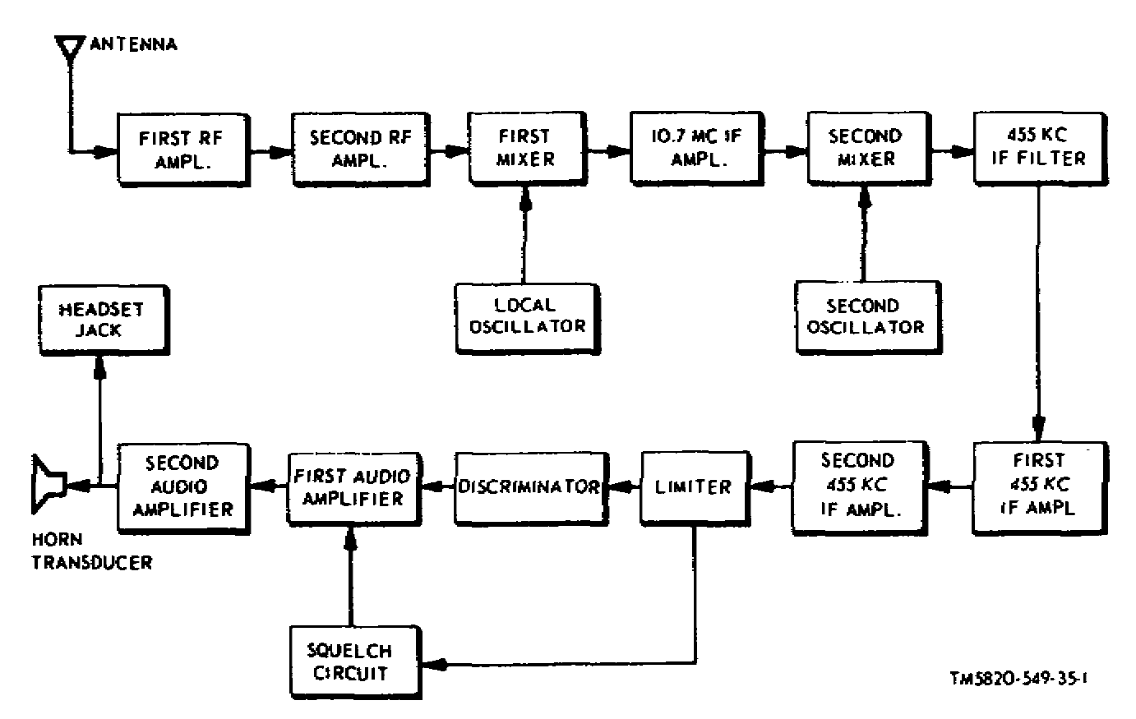

Figure 4-3. Radio Receiving Set AN/PRR-9, block diagram.

4-5. ANTENNA AND RF CIRCUITS

The antenna for the AN/PRR-9 is an 18-inch stainless steel whip-type antenna. Miniature loading coil L1, connected in series with the antenna, is used for tuning out antenna capacitance. Operating the two RF amplifiers (Q1 and Q2) in the common-base configuration eliminates the need for neutralization of the circuits and minimizes the changes in RF gain that are caused by variations in supply voltage. The RF selectivity is obtained through the use of three tunable tank circuits (Cl-Tl, C2-T2, and C3-T3).

4-6 FIRST CONVERSION OSCILLATOR

The first conversion oscillator (Q4) employs a removable miniature crystal in a series-resonant configuration. The oscillator is operated on the low side of the received signal, that is, 10.7 MHz below the RF input signal. A miniature powdered-iron toroid (T5) and an air-trimmer-type capacitor (C7)

42

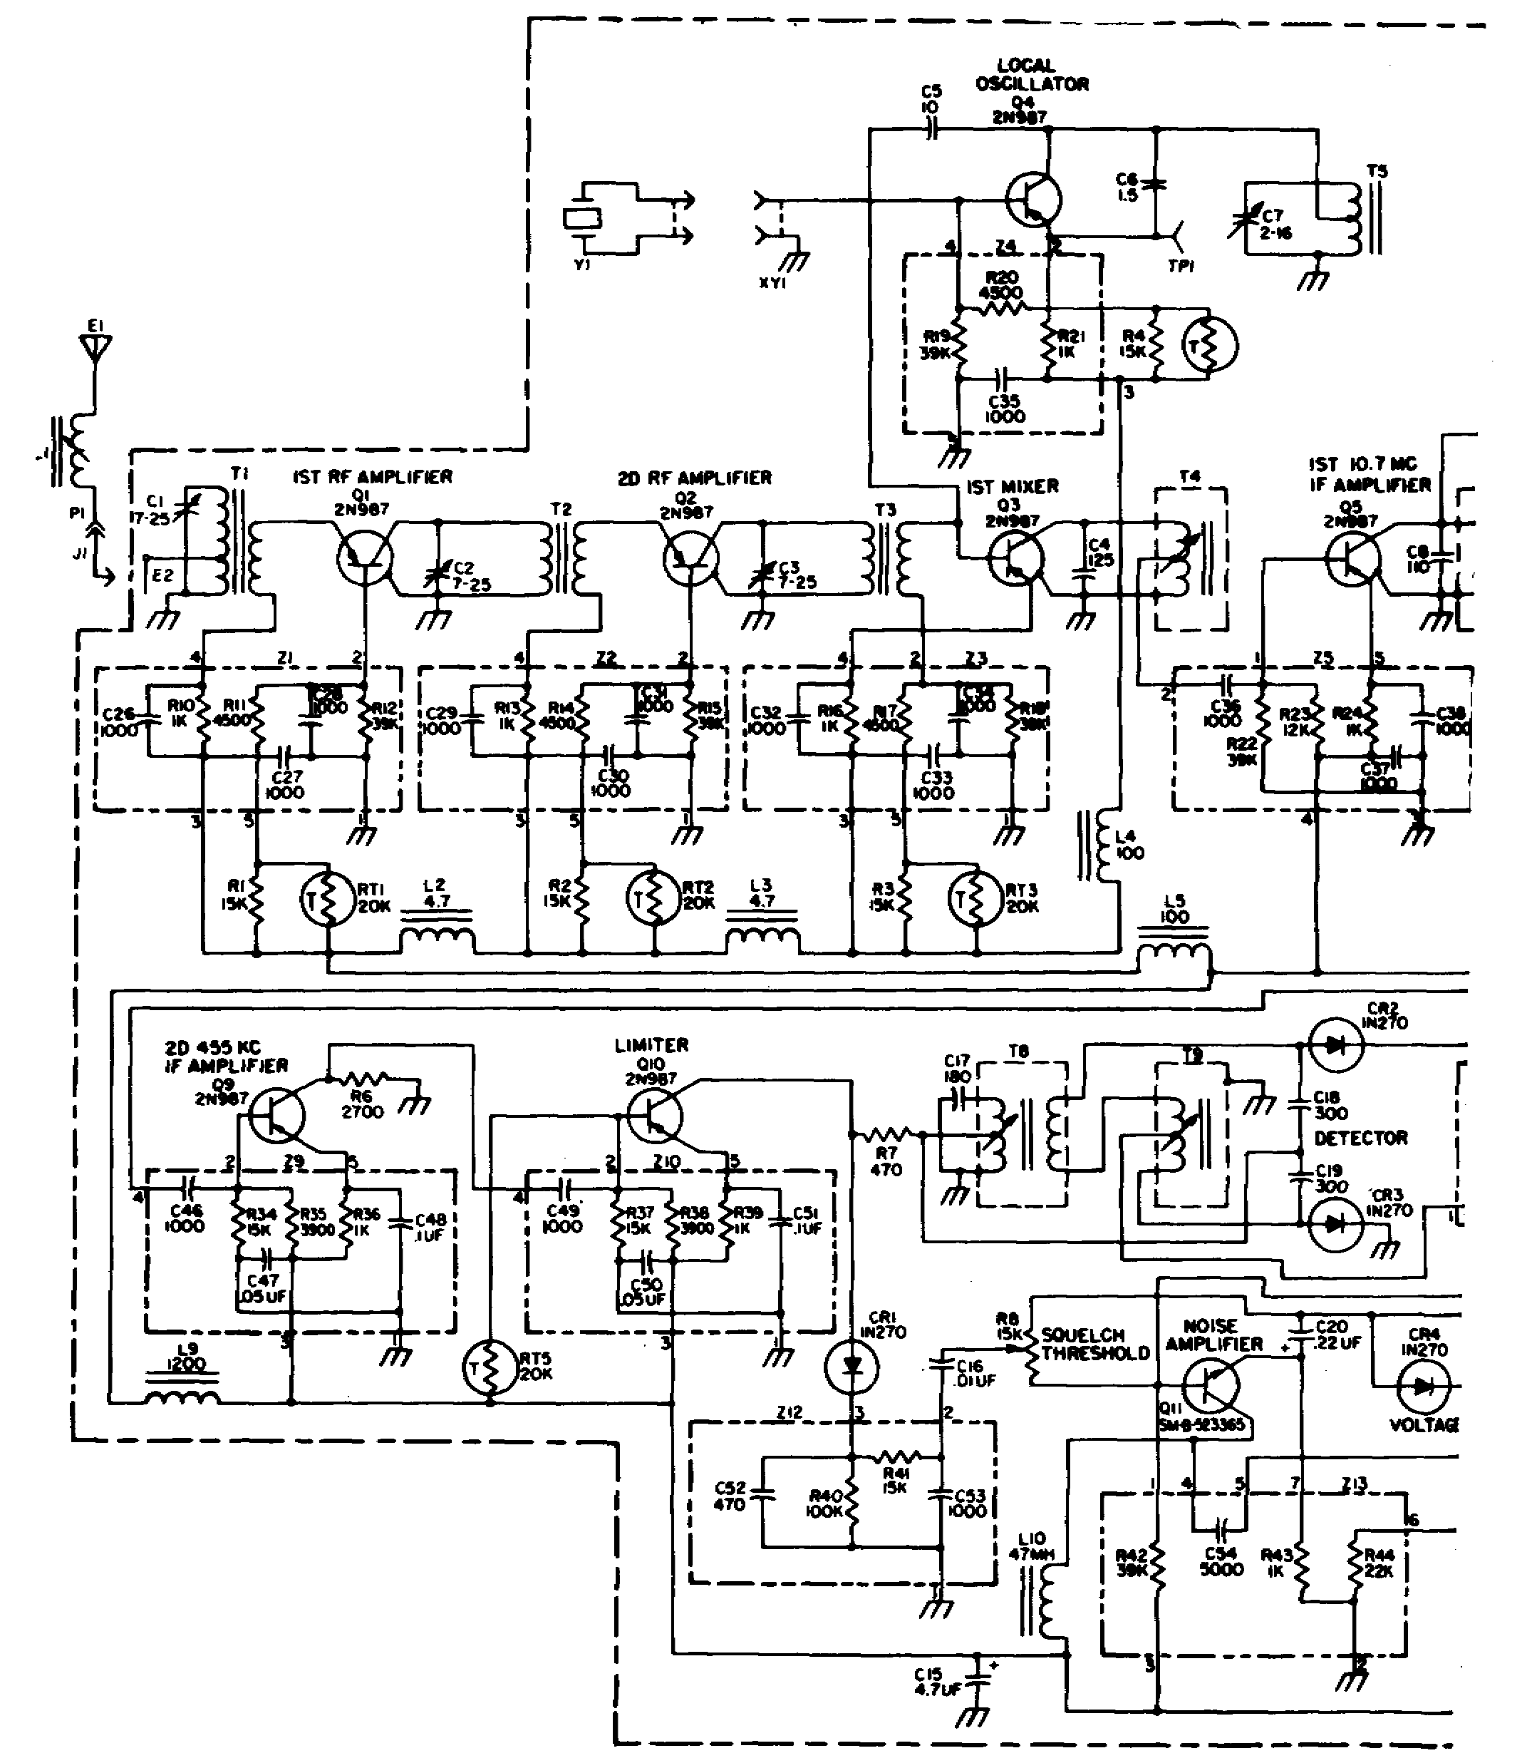

Figure 4-4. Radio Receiving Set AN/PRR-9, schematic diagram.

43

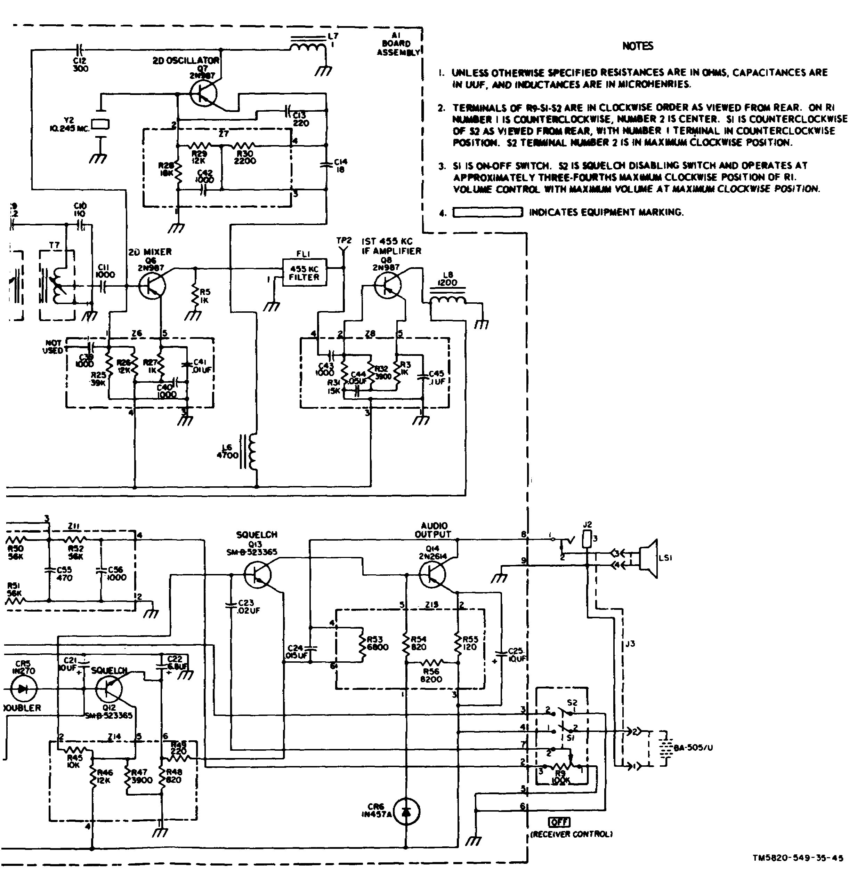

Figure 4-4. Radio Receiving Set AN/PRR-9, schematic diagram. Cont.

44

form the collector tank circuit which must be tuned whenever the crystal frequency is changed. The output signal is extracted from the collector of Q4 and capacitively coupled to the first mixer. The crystal operates on its third overtone mode. Tuning of the oscillator can be checked by monitoring the emitter current at test point TP1.

4-7. FIRST MIXER

The output of the second RF stage and the local oscillator are fed into the first mixer stage (Q3). This stage operates in the common-emitter configuration. Miniature slug-tuned coil T4 serves as the collector load for Q3.

4-8. FIRST IF AMPLIFIER

The first mixer frequency of 10.7 MHz is fed into the 10.7-MHz IF amplifier (Q5), which is operated in the common-emitter configuration. A miniature shielded coil (T6) with a powdered-iron core is used with capacitor C8 to form the tank circuit. The tuning range of the amplifier is restricted to prevent accidental tuning to the second oscillator frequency. The output from the collector circuit is capacitively coupled to tank circuit T7. A low-impedance tap on T7 couples the signal to the base of the second mixer stage.

4-9. SECOND OSCILLATOR

The second oscillator, operating at 10.245 MHz, employs a modified Colpitts circuit with the crystal operating at its fundamental mode. Capacitor C12 provides series-oscillator injection to transistor Q6, the second mixer stage.

4-10. SECOND MIXER

The second mixer operates in the common-emitter configuration with base injection of the second oscillator signal. The output of the 10.7-MHz amplifier is mixed with the output of the 10.245-MHz second oscillator to produce a 455-kHz second IF signal.

4-11. FILTER AND AMPLIFIERS

a. 455-kHz Filter. The major bandwidth characteristics of the receiver are provided by this sealed ceramic filter. The filter has a 6-db bandwidth of approximately 40 kHz and a 60-db bandwidth of approximately 70 kHz.

b. IF Amplifiers. The first and second 455-kHz amplifiers, Q8 and Q9, both operate in the common-emitter configurations. These two circuits require no tuning.

4-12. LIMITER AND DISCRIMINATOR STAGES

Transistor Q10 acts as a limiter stage with increasing signal level; limiting action occurs also at Q9. R7 couples the signal to the primary of discriminator transformer T8. A modified Foster-Seeley type of discriminator is

45

used with IN270 diodes employed for detection. The audio output from the discriminator appears across audio gain control R9.

4-13. AUDIO AND SQUELCH CIRCUITS

The audio signal is fed from the volume control through a 0.02-microfarad capacitor to the base of transistor Q13, which is directly coupled to the audio output stage Q14. The collector of Q14 feeds the transducer horn or the earphone at an impedance of 600 ohms. Squelch is provided through noise amplifier Q11, rectifiers CR4 and CR5, and dc amplifier Q12. The squelch is activated when the volume control is first turned on. Switch S2 grounds the squelch circuitry to deactivate the squelch voltage when the volume control reaches the maximum point on its rotation. The squelch threshold control, R8, is an internal adjustment and normally will not require changing unless a change in receiver characteristics occurs.

4-14. POWER CIRCUIT

Power for this receiver is supplied by a 6-volt battery through switch S1. Silicon diode CR6 furnishes the bias for audio stage Q14. Inductors L2, L3, L4, L5, L6, L9, and L10 isolate the individual stages.

LESSON EXERCISES

In each of the following exercises, select the ONE answer that BEST completes the statement or answers the question. Indicate your solution by circling the letter opposite the correct answers in the subcourse booklet.

1. Squelch circuits are often incorporated in FM receivers to remove background noise during the time that a signal is not being received. A limiter-derived voltage can be used to provide a reduction of background noise by applying the voltage to the

a. discriminator through a squelch tube.

b. audio amplifier through a squelch tube.

c. audio amplifier grid as a negative bias.

d. discriminator plates as a negative bias.

2. The voltage to operate a squelch tube is usually derived from another part of the receiver. The stages that may be used to supply the voltages include the

a. rectifier and local oscillator.

b. dc amplifier and discriminator.

46

c. limiter and local oscillator.

d. limiter and discriminator.

3. The oscillator type of squelch circuit is preferred to other types of squelch circuits in a portable, battery-operated FM receiver because

a. the squelch level is relatively independent of the supply voltage.

b. the circuit needs no adjustment when the battery becomes weak.

c. fewer stages are required to establish the squelch level.

d. the drain upon the battery is negligible.

4. If block V in figure 4-5 represents a ratio detector in the FM receiver, block IV represents

a. a limiter.

b. an IF amplifier.

c. a squelch circuit.

d. a locked oscillator.

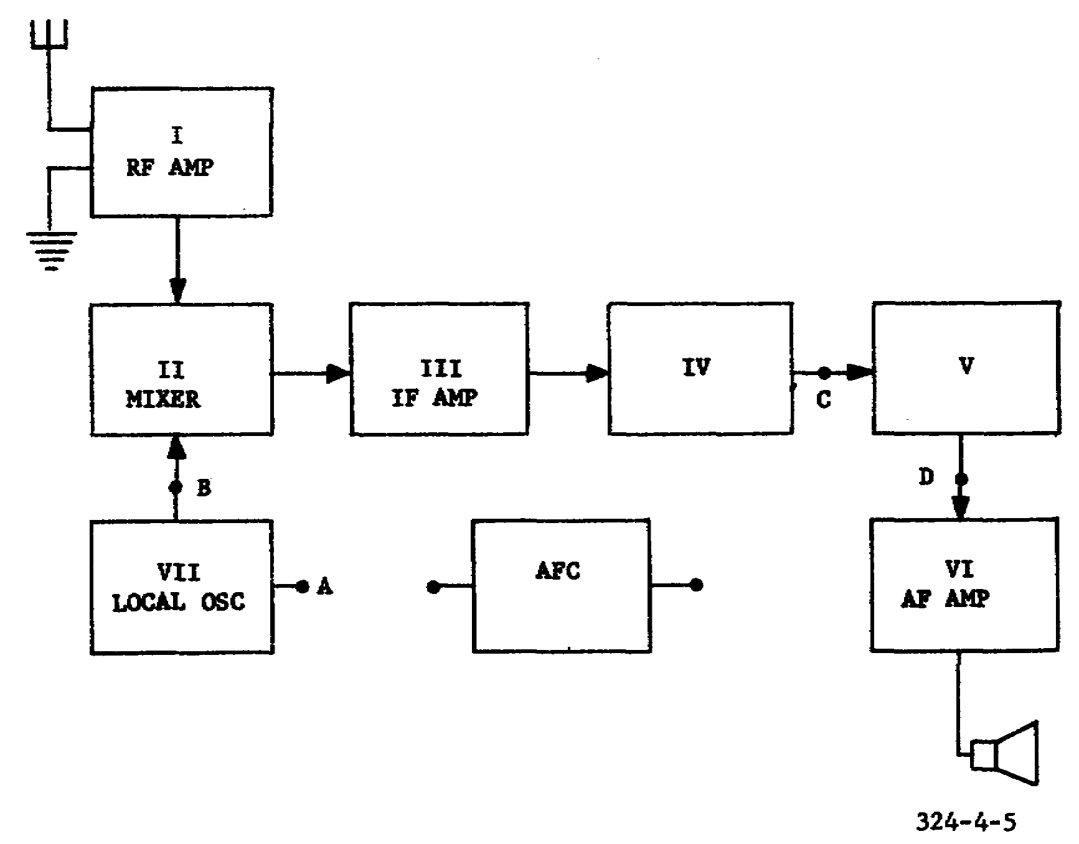

Figure 4-5. FM receiver, block diagram.

47

5. Assume that the FM receiver represented in figure 4-5 is to be equipped with automatic frequency control. If block V is a phase discriminator, what is in the block labeled AFC and where is it connected?

a. Reactance modulator, connected between points A and D

b. Discriminator, connected between points A and B

c. Tertiary coil, connected between points B and C

d. Rectifier, connected between points C and D

6. The FM receiver shown in figure 152 of TM 11-668 incorporates a number of circuits that are typical of FM superheterodynes, including

a. an AFC circuit.

b. a squelch circuit.

c. a de-emphasis network.

d. a double-conversion IF.

7. Compared with other types of multimeters, the major advantage of the vacuum-tube voltmeter in aligning an FM receiver is that it

a. provides a greater range of available voltage scales.

b. can be used to measure both positive and negative voltages.

c. has greater power-handling capabilities for high-voltage measurements.

d. permits more accurate measurements because it consumes less power from the circuit under test.

8. Although the performance of an FM receiver may be improved by a rough alignment, service equipment is required to achieve optimum performance. The equipment used to accomplish accurate visual alignment consists of a

a. signal generator and vacuum-tube voltmeter.

b. FM signal generator and an oscilloscope.

c. synchronizer and an oscilloscope.

d. signal generator and a loudspeaker.

9. When testing the receiver shown in figure 153 of TM 11-668, a signal generator is connected at the grid of V9 and a VTVM is connected across R20 and R21. Since the receiver must handle a deviation of 40 kHz, three different unmodulated test signals of equal amplitude are injected and the VTVM readings noted as follows:

48

415 kHz: +2 volts

455 kHz: 0 volt

495 kHz: -2 volts

The diagnosis of the circuit under test should state that the

a. limiter is not functioning properly and resistor R18 must be adjusted.

b. linearity of the discriminator is poor and the inductance tuning slug in the primary of T6 must be adjusted.

c. discriminator must be tuned to the correct center frequency by adjusting the capacitor in the secondary of T6.

d. tuned circuits are operating normally with respect to linearity and center frequency alignment.

10. At one stage of the alignment of the FM receiver shown in figure 152 of TM 11-668, an FM signal generator is connected to the control grid of V6, and the vertical plates of the oscilloscope are connected across R7. The oscilloscope screen is represented by figure 4-6, in which the solid line represents the actual response and the dotted line shows the ideal response. The component that should be adjusted to obtain the correct response is

a. the capacitor in the plate circuit of V6.

b. the capacitor in the secondary of T3.

c. capacitor C32.

d. resistor R12.

11. When aligning the secondary of the ratio detector in the receiver shown in figure 152 of TM 11-668, a signal generator set to the correct IF is connected to the grid of V6. A VTVM is then connected

a. across R12, while C32 is adjusted to give maximum deflection of the meter.

b. across the secondary of T4, while R12 is adjusted to give maximum deflection of the meter.

c. from the junction of R6 and C20 to the junction of two equal resistors connected across R12, while C32 is adjusted to give zero meter deflection.

d. from the junction of R6 and C20 to ground, while R12 is adjusted to give zero meter deflection.

49

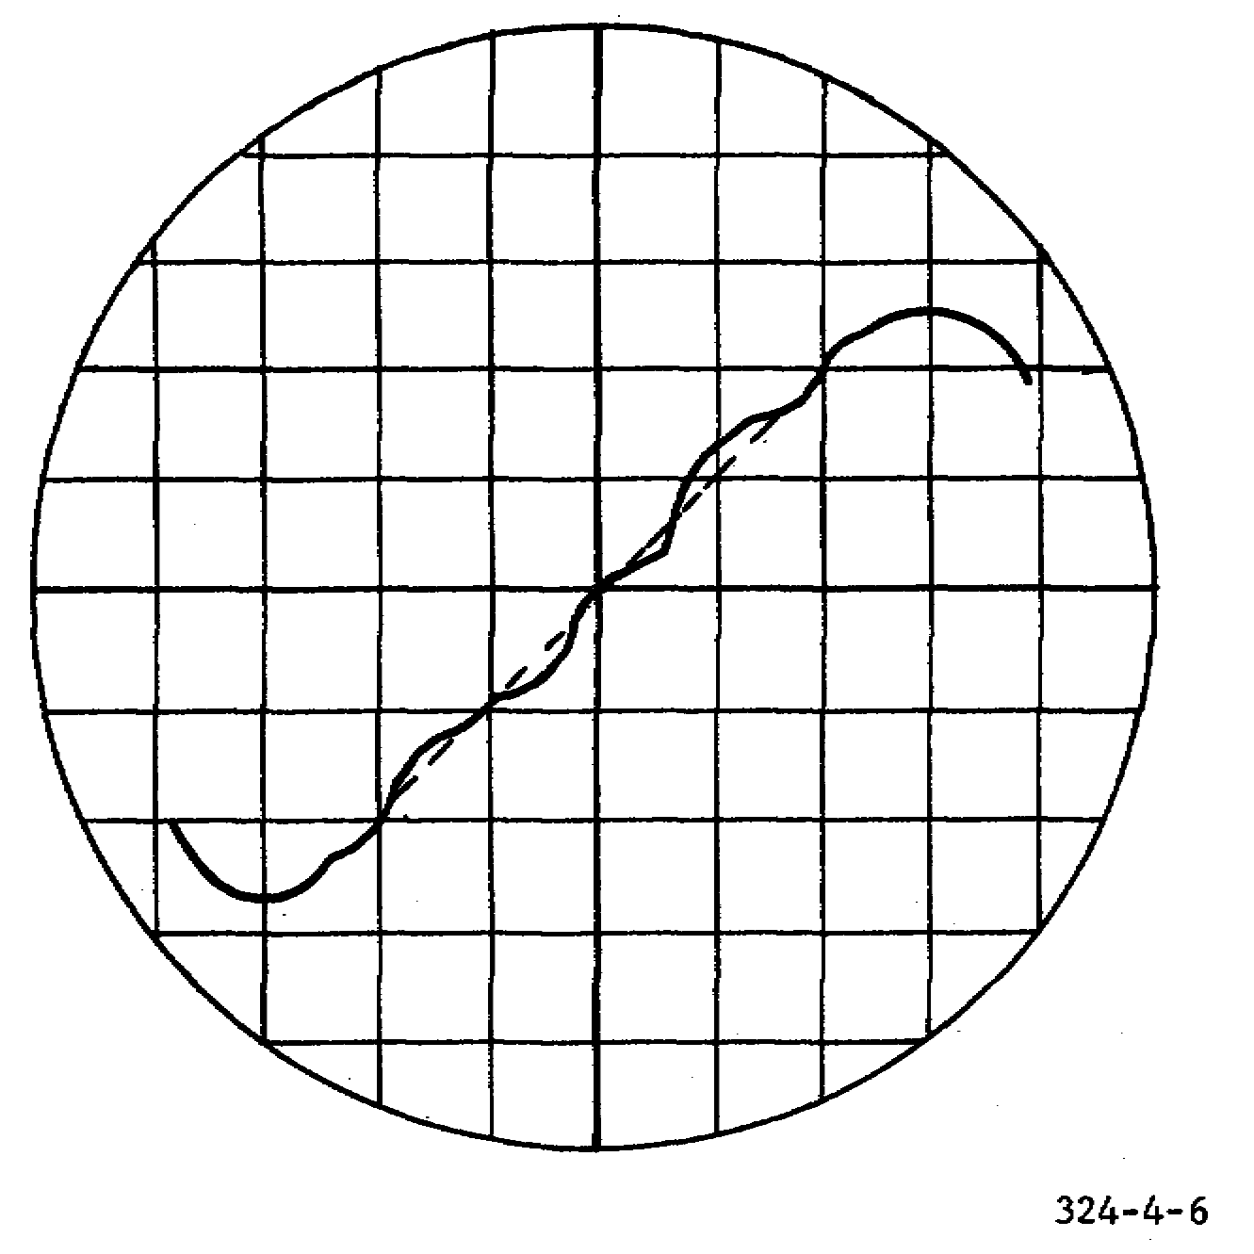

Figure 4-6. Detector response curve.

12. Assume that an FM receiver operating in the 27.0- to 38.9-MHz band is not tracking properly and must be aligned by connecting a signal generator to the grid of the RF amplifier. The frequency at which the receiver tuning control and the signal generator should be set while adjusting the trimmer capacitors is approximately

a. 4.3 MHz. c. 32.9 MHz.

b. 27.0 MHz. d. 38.5 MHz.

13. To illustrate the effect of using a low-resistance voltmeter in aligning a receiver, assume that the voltmeter shown in figure 4-7 has a sensitivity of 20,000 ohms per volt and the indicator is deflected full scale to read 5 volts. If the voltmeter is replaced by one having a sensitivity of 1,000 ohms per volt and a full-scale deflection of 5 volts, the voltage drop across the meter will be

a. less than 1 volt.

b. between 1 and 3 volts.

c. between 3 and 5 volts.

d. greater than 5 volts.

50

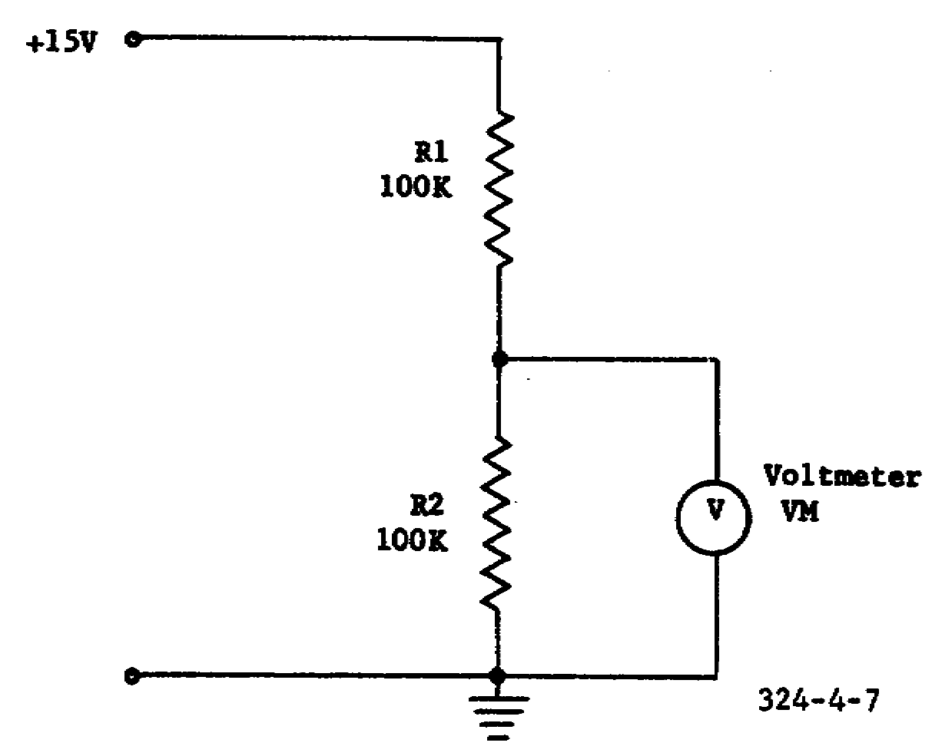

Figure 4-7. Circuit loading with a voltmeter.

14. Assume that a visual alignment is to be made of the final IF amplifier (V8) in the receiver shown in figure 153 of TM 11-668. The oscilloscope is to be connected with its vertical-deflection terminals between the grid of V9 and ground, and the horizontal-deflection terminals connected to a sweep generator. A signal generator and a marker generator are to be connected to the grid of V8. The oscilloscope presentation shown in figure 4-8 indicates that the circuit being aligned is

a. overcoupled with a marker showing the IF limits.

b. critically coupled with a marker showing the IF limits.

c. overcoupled with a marker showing the IF center frequency.

d. critically coupled with a marker showing the IF center frequency.

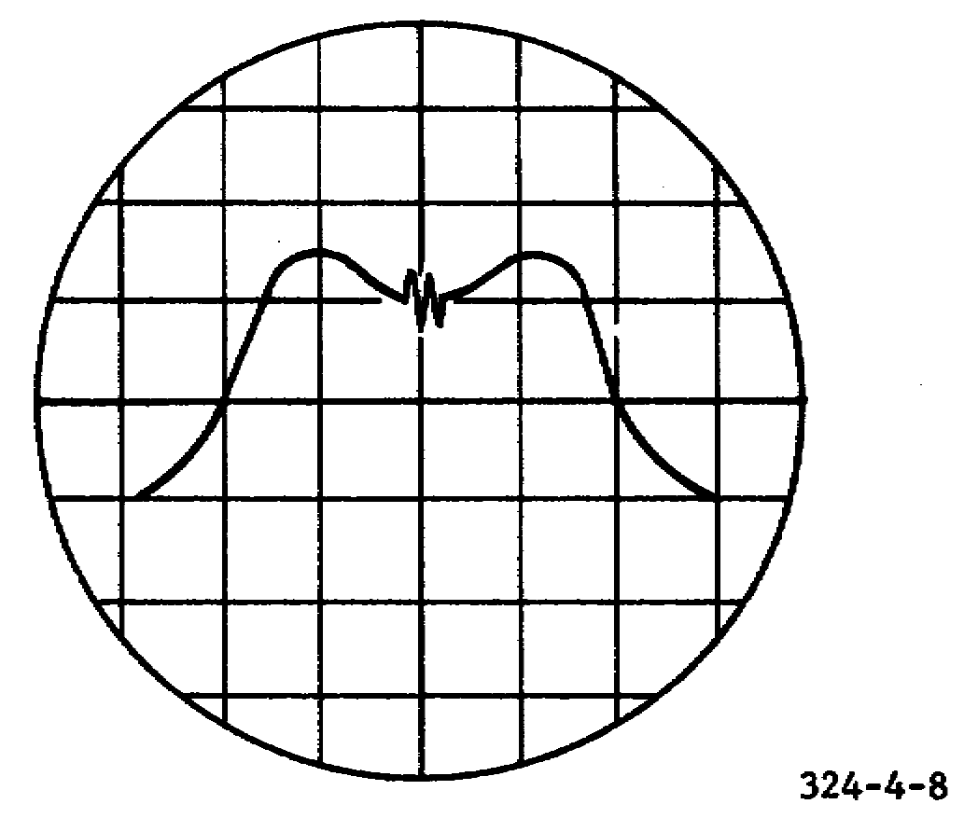

Figure 4-8. Oscilloscope display for IF alignment.

51

15. Assume that the amplifier shown in B of figure 4-1 is one of the IF amplifiers in your FM receiver. What effect will an increase in the carrier signal level have on the forward bias and the gain of the amplifier?

a. Both decrease.

b. Both increase.

c. Bias increases and gain decreases.

d. Bias decreases and gain increases.

16. The squelch voltage in a receiver is derived from the noise signal, carrier signal, or a tone signal. The tone- and carrier-derived squelch voltages are also called

a. new. c. new and old, respectively.

b. old. d. old and new, respectively.

SITUATION

Assume that you have been assigned the task of teaching the theory and operation of Radio Receiving Set AN/PRR-9 to a newly formed maintenance team. The maintenance personnel must be aware of the different frequencies appearing throughout the receiver and also the functions performed by each component within the receiver.

Exercises 17 thru 20 are based on this situation.

17. The selectivity of the receiver shown in figure 4-4 is determined primarily by the components making up the

a. two mixing stages.

b. two 455-kHz amplifiers.

c. two local oscillator stages.

d. three tunable tank circuits.

18. Tunable coil L1, located in the antenna circuit of the transistorized receiver shown in figure 4-4 is used to

a. tune out antenna capacitance.

b. tune out antenna resistance.

c. compensate for antenna conductance.

d. compensate for the neutralizing signal in the first RF amplifier.

52

19. In relation to the RF input signals to the two mixer stages in the receiver shown in figure 4-4, the first and second local oscillators operate at frequencies that are

a. above the RF inputs.

b. below the RF inputs.

c. above and below the RF inputs, respectively.

d. below and above the RF inputs, respectively.

20. The squelch voltage in the receiver shown in figure 4-4 is deactivated either when the volume control is off or when

a. R8 is adjusted.

b. the volume control is maximum.

c. diode CR6 develops an output voltage.

d. limiting stage Q10 reduces the amplitude of the input.

CHECK YOUR ANSWERS WITH LESSON 4 SOLUTION SHEET PAGES 59 AND 60.

HOLD ALL TEXTS AND MATERIALS FOR USE WITH EXAMINATION.

53

LESSON SOLUTIONS

SIGNAL SUBCOURSE 324 FM Radio Receivers

LESSON 1 RF Amplifiers

All references are to TM 11-668, unless otherwise indicated.

1. d--para 55

2. b--para 58b(2), fig. 109

3. c--para 58b(2), fig. 109

Bandwidth = 102.08 MHz - 101.92 MHz

= 160 kHz

Figure 109 shows that the noise voltage for a bandwidth of 160 kHz and an input resistance of 7,000 ohms will be approximately 4 microvolts.

4. c--para 58c

5. b--para 58d, fig. 109

According to the table in paragraph 58d, hexodes have an equivalent noise resistance of about 200,000 ohms. In figure 109, the intersection of the lines representing 200,000 ohms and 100 kHz indicates a noise voltage of approximately 20 microvolts.

6. a--para 59b, c

7. a--para 60a

Screen current given as 3 ma

Plate current at -1 grid volt is 10 ma (from fig. 1-4)

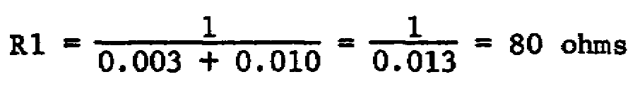

55

8. b--para 61d

Adding a -4-volt AVC potential to the -2-volt control-grid bias will set the control grid at -6 volts. Figure 1-4 shows that the plate current will increase approximately 1/3 ma when a 1-volt positive signal reduces the grid voltage to -5 volts.

9. c--para 60b(5)

10. a--para 60d, 61a, c(1)

11. d--para 60a, 61b(4)

12. d--para 60d-f

13. b--para 61c

14. c--para 61d(2)

15. a--para 70d(2)

16. a--Attached Memorandum, para 1-1

17. b--Attached Memorandum, para 1-la, c

18. d--Attached Memorandum, para 1-2

19. c--Attached Memorandum, para 1-2d

20. a--Attached Memorandum, para 1-1c, 1-3

LESSON 2 Mixers, Converters, and Local Oscillators

All references are to TM 11-668, unless otherwise indicated.

1. c--para 62a

Normally, the first local oscillator in a communication receiver in this frequency range will operate at a lower frequency than the incoming signal. The second oscillator will operate at a higher frequency than the first IF.

1st Osc frequency = Incoming frequency - IF

+ 35.0 - 4.3 = 30.7 MHz

2d Osc frequency = 1st IF + 2d IF

= 4.300 + 0.455 = 4.755 MHz

56

2. d--para 62b

3. b--para 62d, e

IIF = Gc x ERF

= 4,000 x 10-6 x 0.28 x 320 x 10-6

= 0.36 microampere

EIF = IIF x RL

= 0.36 microampere x 2,000 ohms

= 720 microvolts

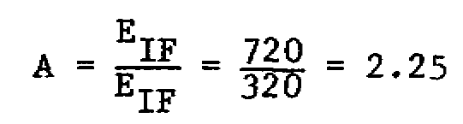

4. a--para 63a(2)

Taking the extreme case, it can be seen that if the input signal is 88 MHz, an image frequency of 108 MHz will be obtained when the IF is 10 MHz. That is, 88 MHz + (2 x 10 MHz) = 108 MHz. Hence, an IF of 10.7 MHz will insure that the image frequency will be outside of the frequency band.

5. b--para 63b

6. a--para 63e

7. b--para 63e(l)

8. d--para 63e(l)

9. b--para 64-66

10. c--para 64-66

11. c--para 62d, e; 64

The conversion gain obtainable from a mixer depends on the conversion transconductance and the circuit alterations to counteract noise. The diode provides no conversion gain and the noise introduced in the triode and pentogrid mixers limit their conversion gains. Since the pentode has an extremely high conversion transconductance and permits high voltage gain, it provides the greatest conversion gain.

12. a--para 65

57

13. c--para 66

Since the crystal mixer circuit is basically the same as the diode circuit, and neither the crystal nor the diode produce a voltage gain, the crystal mixer provides no conversion gain.

14. d--para 67b

15. b--para 68a, c, d,

16. d--para 68c, d

17. a--Attached Memorandum, para 2-1b

18. d--Attached Memorandum, para 2-1b, 2-3

19. d--Attached Memorandum, para 2-5a(l)

20. a--Attached Memorandum, para 2-5c(2)

LESSON 3 IF Amplifiers, Limiters, and Detectors

All references are to TM 11-668, unless otherwise indicated.

1. c--para 72b

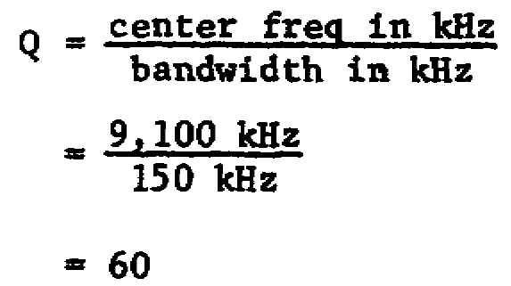

2. b--para 72b

Since a 3-db reduction is realized for each tuned circuit, the signal power is reduced 18 db after six tuned circuits.

3. c--para 72b, 73a

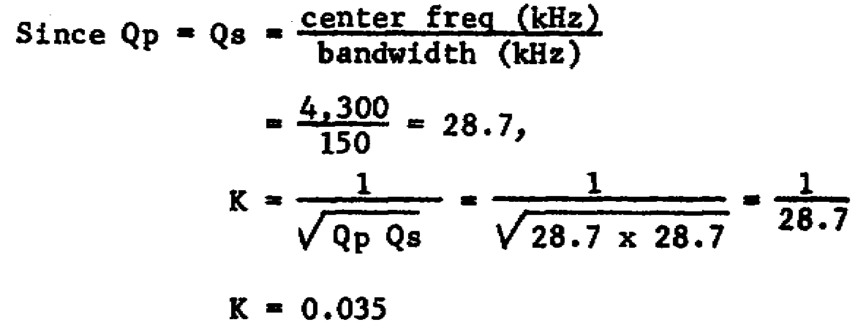

58

4. d--para 73

5. a--para 73c(2), (3)

6. c--para 73d

7. d--para 74a

8. c--para 74b(3)

9. b--para 75a

10. a--para 75b, c(2)

11. b--para 77; Attached Memorandum, para 3-4a

If the discriminator is to produce an output that is distortion free, it must operate on the linear portion of the characteristic curve. The linear portion of this curve extends approximately from 5.96 MHz to 6.04 MHz, or for 0.08 MHz. This is equal to 80 kHz.

12. c--para 78, fig. 141

V1 and V2 form a series-connected voltage divider. Since current flows one way, as shown in figure 141, the output will be a constant negative dc.

13. b--para 78a, b

14. d--para 78c

15. d--para 79a(4)

16. c--para 80

The cycle-counting detector requires no alignment.

17. c--Attached Memorandum, para 3-3

18. c--Attached Memorandum, para 3-3a

19. a--para 77, fig. 140; Attached Memorandum, para 3-4a

20. d--Attached Memorandum, para 3-5b

LESSON 4 Special Circuits and Alignment

All references are to TM 11-668, unless otherwise indicated.

59

1. d--para 83c, C of fig. 148

2. d--para 84, 85b

3. a--para 86b

4. b--para 78a, 89

5. a--para 88

6. c--para 89a(3)

7. d--para 94, 95a(2); Attached Memorandum, para 4-3d

8. b--para 94, 98a(1)

9. d--para 95a(l)

10. a--para 95b, 98d

11. c--para 95b(l), (2)

12. d--para 97

13. a--para 97; Attached Memorandum, para 4-3

Input impedance of the 20,000-ohm/volt meter on the 5-volt scale = 5 x 20,000 = 100K. So the parallel combination of R2 and 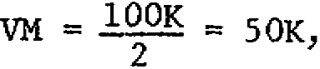 and the voltage across VM = 5 volts, so stated in the exercise.

Input impedance of the 1,000-ohm/volt meter on the 5-volt scale = 5 x 1,000 = 5,000 ohms.

The parallel combination of R2 and VM 2 = 4,760 ohms. Therefore, the new voltage across R2 and VM is approximately 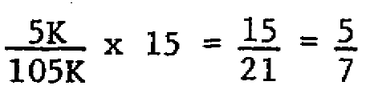 volt, or 0.71 volt.

14. c--para 98b(3)

15. c--Attached Memorandum, para 4-1b(2)

16. c--Attached Memorandum, para 4-2

17. d--Attached Memorandum, para 4-5

18. a--Attached Memorandum, para 4-5

19. b--Attached Memorandum, para 4-6, 4-9, 4-10

20. b--Attached Memorandum, para 4-13

60

